EFICIENCY OF KNOWLEDGE USE FOR ESTABLISHING

Lăcrămioara-Rodica HURLOIU¹
e-mail: hlacra@yahoo.com
Bianca-Florentina RUSU²
e-mail: bianca_preda1974@yahoo.com
Ion-Iulian HURLOIU³
e-mail: iulian.hurloiu@gmail.com
Odi-Mihaela ZĂRNESCU⁴
e-mail: odimihaela@yahoo.com
^{1,2,3,4}Spiru Haret University

Abstract: The research and development field provides driving forces of economic growth. EU economy, including the national economies under the impact of scientific research and inventions results, turn into a multi-structural system. The intellectual development of the society is the most powerful productive force.

Key words: knowledge, information, argument, technologic, production

JEL Classification: G32, M10, O11

Introduction
The last decades have marked awareness of the particular importance that information and knowledge have for social-economic development. More and more scientific personalities and specialists in the area of information emphasize their increased role in the modern age. Alvin Toffler argues that the third source of power that tends to become predominant in the future is information. At the same time, the Romanian scientists together with the authors plead and claim that information and communications are more and more a production force and the obtained information is a part of national wealth.

Methods
The problem addressed has a great theoretical significance. The analyzes, arguments, mathematical models, principles, goals, could all be the base of methodology for scientific researches in the field of creating the knowledge society, the scientific elaborations that shall become the Technological Revolution of the 21st Century.

Results
Unfortunately, it is often found that the volume of essential information possessed by the members of an organization or country do not favor this process. From this point of view, the graphic from figure 1 below is self-evident, from which it results that only a small proportion of the components of a system possesses a great deal of knowledge and information, most of them possess a limited amount of knowledge. For these reasons, it is necessary to increase the maximum point and move the curve to the right, indicating an increase in the possession of knowledge as well as the increase of the number of people that are part of this category with a large amount of knowledge.
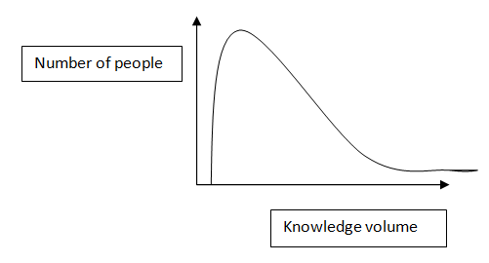
Fig 1. Typical situation of the volume and distribution of knowledge in a system (source: O. Niculescu, Economics, Company and Management based on knowledge, Economics Publishing, Bucharest 2007)

Comparing this distribution knowledge in a developed country and in a developing country we obtain the graph from figure 2 in which curve A reflects the situation is a developing country and curve B in a developed country.

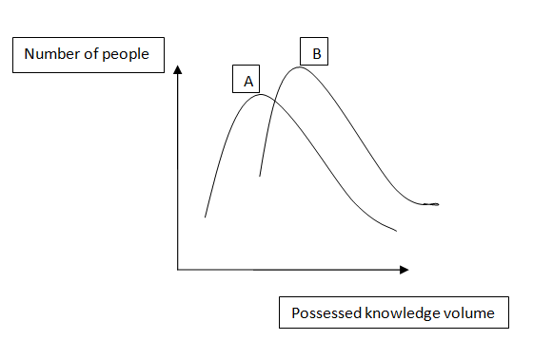
Fig 2. Evolution and distribution of knowledge in two countries with different development levels (source: O. Nicolescu, Company and Management based on knowledge, Economics Publishing, Bucharest 2007)

Intellect, according to the DEX (the Romanian Explicative Dictionary) is the ability to think, know, have rational activity, to operate with notions, mind, thinking, reason. What the intellect produces, namely – ideas, are called intellectual products. Intelligence is the ability to understand easily, to grasp what is essential and to solve situations or problems based on past experience. Artificial intelligence is the ability of advanced technical systems to achieve quasi human performance. In this context, the products created by the intellect, intelligence (ideas, knowledge, innovation etc.) represents “intellectual products” or “smart products”.
Knowledge is needed to generate ideas. Knowledge, however wide would be, is ineffective. Only knowledge-based products under certain conditions could have economic, ecological, social, military, political impact. A statement such as “the efficiency of knowledge” in our view is questionable.
At present, any country that does not progress in the research and development sector, is economically and socially regressing. In order to advance in the scientific field to the level of EU member states, candidate countries have to make considerable efforts by developing and applying future sciences. It is necessary to motivate innovative activities, to involve private capital in the research and development field. We consider the need to stimulate mutual cooperation between companies of the candidate countries to the EU, and companies from highly developed industrial countries in order to achieve the import “of ideas” and state-of-the-art technologies. It is useful to organize the application of innovations in all areas of human activities.
At present, in the European Union, all the development activities for knowledge and use of it, are coordinated by programs (plans).
The research and development field provides driving forces of economic growth. EU economy, including the national economies under the impact of scientific research and inventions results, turn into a multi-structural system. The intellectual development of the society is the most powerful productive force.
The knowledge society is possible only graved onto the information and cannot be separated from it. At the same time, it is more than the information society through its major role that comes to information – knowledge in society.

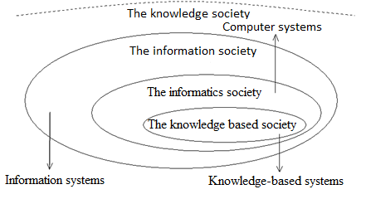
Fig. 3 The concept of knowledge society

In the past, a country could have become developed if it had natural wealth, geographical location and favorable climatic conditions. Currently, a country shall become rich only if it is “rich in ideas”. The list of key factors that could contribute to development, in our view, includes the following:
1. Low levels of uncertainty of possible options for fundamental scientific research, applied research, innovations, and their use in the creation of new technologies (X₁).
2. Sufficiently large number of industrial companies generating innovative technologies in production, non-production spheres, service providers (X₂).
3. Significant share of financing of research and development in GDP (X₃).
4. Increased number of scientific researches, innovators at 10000 inhabitants (X₄).
5. Effective use of information technologies in all country activities (X₅).
6. Large number of scientific products produced in the country, imported in the country (X₆).
7. High level of education, in general (X₇).
8. Developed infrastructure for scientific research, innovation, design and implementation of their results (X₈).
9. Higher technological level in the country in territorial, branch, micro and macro level (X₉).
10. Demand/request from the economic subjects in the country regarding innovation, ideas in the field of research and development (X₁₀).
11. Sufficiently large number of well-prepared specialists (critical number), generators of ideas, inventions in the research and development field (X₁₁).
12. High level of technological development of economic activities in the country, percentage of primitive technologies based on the use of cheap manual labor in the country (X₁₂).
13. Effective training technologies, high teaching quality of school textbooks (X₁₃).
14. Significant expanded level of scientific, educational, innovative, internship cooperation with countries that are developed in research-development field (X₁₄).
15. High level of motivation for work, including remuneration of the results achieved by the authors in the field of research and development (X₁₅).
16. Effective organization of research and development activities in the area by the government, by the managers of academic system, inclusively by using the methods “program-purpose” (X₁₆).
17. Level of labor remuneration in the country below the level of labor remuneration in the research and development field, in territorial, branch, micro profile (cheap labor – does not create innovative needs) (X₁₇).
18. Number and seriousness of the problems faced by society in all human activities, including economics, ecology, social, medical, institutional area etc. (X₁₈).
19. Effective ways to accumulate scientific ideas, innovative in the country and inclusively abroad (X₁₉).
20. Effective ways of organizing continuous education in all human activities (X₂₀).
21. High level of remuneration for authors’ work for publication of ideas, innovations in research and development area (excluding cases when authors are obliged to bear the costs for publishing their works) (X₂₁).
The elements mentioned above represent the minimum necessary conditions to achieve success in the field of research and development, the creation of nanotechnologies in order to endure the competitive economic and social growth of the EU countries.
Economic growth (GDP) could be correlated with the listed factors by formulating a production function, which can be written as follows:
Y=F(x₁,x₂,...x₂₁) (1)
where x_{i} ≥0, i=1,2,...,21
A particular case of function [2.1] is function Cobb-Douglas:
(2)
where A= proportionality coefficient; x_{1……..}x₂₁=the 21 perturbation factors of social economic development; parameters α_{i}, where i=1…..21 – quantifying the elasticity of respective factor.
To simplify the stated aspects, function [2.2] is expressed in natural algorithms:
(3)
By derivation of the equation [2.3] with respect to x_{i} , i=1,2...21 we obtain the following:
, i=1,2,...,21 (4)
Which could be also be written:
, i=1,2...,21 (5)
By summing the equations [2.5] it is obtained the following relation
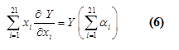
From [2.6] equation it results that GDP (Y) of the country (exemplified for Romania and the Republic of Moldova) could be multiplied by or what represents the elasticity of GDP in relation to the variables x_{i} , i=1,2,...,21. At the same time the amount may be:
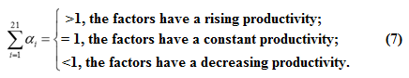.
The form of production function (2.1) is of principal importance. The production function should not only give us data about the country’s GDP evolution under the impact of stated factors, but it is appropriate to describe evolutionary processes. Function (1) must possess the following properties: be continuous, be non-negative for any positive values of the variable x_{i} , i=1,2,...,21; to have unique values, well-determined, under restriction; to convert to zero if one or more of the factors x_{i} , i=1,2,..,21 are equal to zero, to be differentiable; reducing the impact of a factor can be complimented by the effort of another factor among the 21 factors; the elasticity of GDP is determined by the efficiency of each factor; the values of the 21 factors determine the extreme GDP; mathematical transformations could be interpreted economically. Function (1) linear, parabolic, hyperbolic type, Coob-Douglas, Mitcherlih-Baul, Spliman, Balmucand, Lomax type do not satisfy the above listed conditions (properties). To deduce the form of function (1) the examination of GDP evolution is reduced for the case when it depends on a single factor – x_{1.}
It is admitted that function (1) has the form Y=F(x₁), GDP depends only on the x₁ factor. We note by b₁- the increase of the GDP logarithm to a unit of logarithm increase of factor x₁; b₁lnx₁- GDB logarithm increase to lnx₁ growth units of factor x₁; γ₁x₁-increase of x₁ factor, γ₁-proportionality coefficient.
- increase of GDP logarithm to a growth unit factor x₁. Therefore or . Similarly, could also be interpreted the contribution of factors i=2,3,...,21 to the increase of GDP. Function (2.1) will take the form:
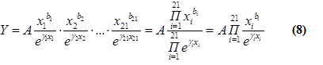
In this interpretation, the element plays the role of mathematical norm, each factor i, i=1,2,...,21 being normalized. The elasticity of GDP in relation to the variable x_{i}, i=1,2,...,21 is:
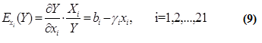
Determining the GDP elasticity to a growth unit factor i, i=1,2,...,21 is:
This result could be interpreted: GDP under the impact of the knowledge factor $x_{1}$increases but these (GDP growth) are decreasing.
Function (8) are extremum (maximum), obtained from the system:
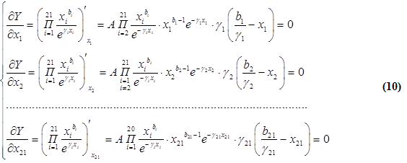
It is determined - I value factor, i=1,2,...,21 for which GDP shall have extremum.
Whereas >0 , then for →GDP shall be maximum.
For X< GDP growth shall be positive, >0.
For X> , GDP shall decrease.
Further on, the parameters are determined. In some cases these parameters can be determined by using the minimum squares method and in others the method of analyzing expert data is used.
It results that each scientific area, research direction can be quantified by various criteria. These criteria may also constitute an incompatible system. Economic criteria and fundamental science criteria, most of the time generate a present negative profit, but in perspective could create considerable profits. Under these circumstances, the selection of directions could only be performed by experts in different areas.
For every area, the direction of scientific research d_{i} (i=1,2,...,m) is estimated considering the criteria ,( j=1,2,...,n).
Area d_{i}, by criteria are assigned by experts’ d_{ij} points. J criteria are also estimated, (j=1,2,...,n) to which they correspond α_{j} points (percentages in relation to the total), . 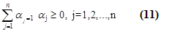
Therefore, represents the estimation of i domain by the percentage of criteria, i=1,2,...,m. In other words, domains d₁,d₂,...,d_{i},...,d_{m} are estimated by the product:

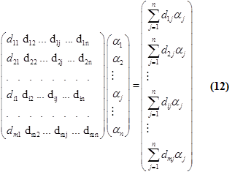
The research direction (field) d_{i}, (i=1,2,...,m) is measured by the specialists in the field considering the estimated criteria (according to the level of importance, actuality, gravity etc.) in the respective fields of scientific research.
To the field (direction) d_{i}, i=1,2,...,m are assigned points.
The directions or areas where research is needed cannot always be covered with scientific, innovative, experimental potential of EU countries. In these cases, some research areas shall be excluded from the scientific research nomenclature, introducing variables. The vector of areas, directions with national scientific coverage is determined by the product:
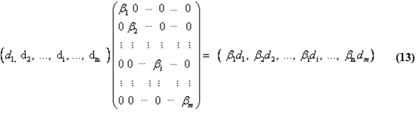
where ,
In which:
1, if i area is investigated in Romania
0, if i areas is investigated in EU
Starting from the scientific, innovative, creative potential, from the investigative processes infrastructure, with the variables divided/designed a D matrix consisting of elements in matrices and, where is the selective matrix of research for the scientific potential of EU countries; and - for researchers from another regional area:

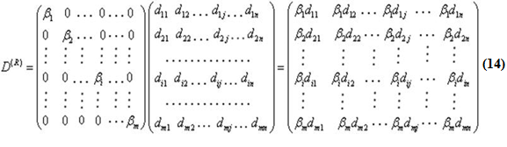
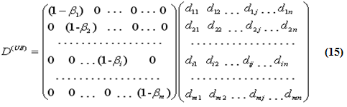
The main directions, research and development areas (i) are: communicative information systems; science about life; sustainable economic development; nano-sytems industry; transport systems; energy systems. The knowledge of society turns into means of producing the ideas of solving the problem: as well is for the future to be built; we start from available knowledge; how the knowledge of society has developed in order to succeed in building the future. In the processes of studying the future, we need to consider the following three problems: to be predicted, to be aware of, to be solved.
The above calculation elements are significant for examining/evaluating advance investments towards the knowledge based on society.
Basic, applicative, innovative science could contribute to the upgrading of traditional technologies, but could also create new core technologies, called nanotechnologies.
The conclusions to be drawn are the following:
- The minimum level of knowledge in a developed country is significantly higher than in a country in development;
- The maximum level of knowledge possessed by the most informed people in countries in development is clearly lower than the people and their number in developed countries;
- The number of informed people at a high level in developed countries is significantly higher than that of its counterparts in countries in development;
- The volume of knowledge and information is bigger and higher in a developed country than in a country in development.
Hence, the conclusion that the countries in development reach the developed countries from information point of view, curves A and B to identify or at least to be close to the four plans considered. The resulting solution is that of performance of a massive transfer of knowledge and knowledge management through all possible paths: macro, meso and micro-social.
The magnitude and speed of management knowledge transfer is conditioned by the following factors: the size of the companies, the openness of society, the people’s freedom of movement between countries, the control and regression of people at macro and micro-social level, the degree of knowing foreign languages by a country’s population, and especially its level of preparedness.

References:

1. Aliyev Azad, G. (2013) Economical and mathematical models subject to complete information. Ed. Lap. Lambert Akademic Publishing, Berlin
2. Andersen, T.G., Bollerslev, T. and Dicbold, F.X. (2002), Parametric and Nonparametric Volatility Measurement, NBER Working Paper No. T0279
3. Andronie, M. (2015) Ensuring Security Of Data Used By Economic Organizations For Decision Support, The 21th international scientific conference Knowledge-Based Organization, “Nicolae Bălcescu” Land Forces Academy Publishing House, ISSN 1843-6722, Sibiu
4. Anderson, R. E. (2008). Implications of the information and knowledge society for education. In International handbook of information technology in primary and secondary education (pp. 5-22). Springer, Boston, MA.
5. Bleiklie, I. (2005). Organizing higher education in a knowledge society. Higher education, 49(1-2), 31-59.
6. Carnoy, M., & Castells, M. (2001). Globalization, the knowledge society, and the Network State: Poulantzas at the millennium. Global networks, 1(1), 1-18.
7. Carlaw, K., Oxley, L., Walker, P., Thorns, D., & Nuth, M. (2006). Beyond the hype: Intellectual property and the knowledge society/knowledge economy. Journal of Economic Surveys, 20(4), 633-690.
8. Cetina, K. K. (2007). Culture in global knowledge societies: Knowledge cultures and epistemic cultures. Interdisciplinary science reviews, 32(4), 361-375.
9. David, P. A., & Foray, D. (2002). An introduction to the economy of the knowledge society. International social science journal, 54(171), 9-23.
10. Dubina, I. N., Carayannis, E. G., & Campbell, D. F. (2012). Creativity economy and a crisis of the economy? Coevolution of knowledge, innovation, and creativity, and of the knowledge economy and knowledge society. Journal of the Knowledge Economy, 3(1), 1-24.
11. Enders, J. (1999). Crisis? What crisis? The academic professions in the'knowledge'society. Higher Education, 38(1), 71-81.
12. Ermakova, A.A. (2015) Development of methodology of construction educational ergonomics systems. Primo Aspectu 24, No 10 (174):122–124
13. Frank, D. J., & Meyer, J. W. (2007). University expansion and the knowledge society. Theory and society, 36(4), 287-311.
14. Gilbert, J. (2005). Catching the Knowledge Wave?: The knowledge society and the future of public education in New Zealand. Education Policy Directions in Aotearoa/New Zealand, 53-70.
15. Grzega, J., & Schöner, M. (2008). The didactic model LdL (Lernen durch Lehren) as a way of preparing students for communication in a knowledge society. Journal of Education for Teaching, 34(3), 167-175.
16. Gurgu Elena, World Economy, Tomorrow's Romanian Publishing House, Bucharest, 2011
17. Gurgu Elena (2018). Ethics in Business, Romanian Tomorrow Foundation, Bucharest
18. Gurgu Elena (2018). Implementation of ethics management nowadays in the romanian university environment
19. Hansson, F., Husted, K., & Vestergaard, J. (2005). Second generation science parks: from structural holes jockeys to social capital catalysts of the knowledge society. Technovation, 25(9), 1039-1049.
20. Harris, R.D.I., Sollis, R. (2003), Applied Time Series Modelling and Forecasting, JohnWiley.
21. Hochgerner, J. (2012). New combinations of social practices in the knowledge society. In Challenge Social Innovation (pp. 87-104). Springer, Berlin, Heidelberg.
22. Henkel, M. (2007). Can academic autonomy survive in the knowledge society? A perspective from Britain. Higher Education Research & Development, 26(1), 87-99.
23. Livingstone, D. W. (1999). Lifelong learning and underemployment in the knowledge society: A North American perspective. Comparative education, 35(2), 163-186.
24. Lytras, M. D., & Sicilia, M. A. (2005). The Knowledge Society: a manifesto for knowledge and learning. International Journal of Knowledge and Learning, 1(1-2), 1-11.
25. Rabeharisoa, V., Moreira, T., & Akrich, M. (2014). Evidence-based activism: Patients’, users’ and activists’ groups in knowledge society.
26. Stock, W. G. (2011). Informational cities: Analysis and construction of cities in the knowledge society. Journal of the American Society for Information Science and Technology, 62(5), 963-986.
27. Sahlberg, P. (2010). Rethinking accountability in a knowledge society. Journal of Educational Change, 11(1), 45-61.
28. Yakovlev, N.M. (2006) Game-theoretical model of the labor market in the region (PhD Thesis), Kemerovo
29. Välimaa, J., & Hoffman, D. (2008). Knowledge society discourse and higher education. Higher education, 56(3), 265-285.
30. Zaharia, S. E., & Gibert, E. (2005). The entrepreneurial university in the knowledge society. Higher Education in Europe, 30(1), 31-40.
31. Walby, S. (2011). Is the knowledge society gendered?. Gender, Work & Organization, 18(1), 1-29.
32. Willke, H. (2007). Smart governance: governing the global knowledge society. Campus Verlag.
33. Wooldridge, J. (2006) Introductory Econometrics. A Modern Approach, third edition. Thomson, South Western: Mason, OH

