THE DEVELOPMENT OF THE TRAVEL AND TOURISM INDUSTRY IN THE WORLD

Bogdan SOFRONOV¹
¹University Politehnica of Bucharest, Splaiul Independenței 313, Bucharest 060042, Romania
Email: bogdansofronov@yahoo.com

Abstract
The purpose of this paper is how the travel and tourism industry are changing and development in the world.
Travel and tourism industry is one of the world's great industrial sectors. It drives economic growth, creates jobs, improves social development and promotes peace.
Hundreds of millions of people around the world are dependent on the sector for their employment. In some island economies, travel and tourism industry is not just the biggest employer, it is effectively the only employer. The role is to contributing to the creation of sustainable economies.
Travel and tourism industry is a diverse sector consisting of millions of companies and employers, from the biggest global travel brands to the smallest tour operator or hostel owner. Together we form a formidable force with a voice to be heard at the highest levels of society and government.

Key words: development; travel; tourism; tourism industry; international tourism.
JEL Classification: Z30, Z32

Introduction
From an economic and social point of view, the development of travel and tourism industry is reflected in an increasing demand of the population for an ever-increasing range of consumer goods and services, a demand that stimulates the manufacturing and service sectors, leading to an increase in economic activity and consumption , independent of the normal evolution of market trends. As a consequence, this increase in tourism consumption, caused by massive seasonal movements of the population towards certain destinations of tourist interest and increasing the number of visitors, is favorable to the complex development of the economy of some tourist areas and of the economic ensemble of the countries which is developing its tourism industry.
In other words, in step with the increase in the demand for tourist services, a distinct offer of services has gradually developed, whose volume and structures imposed the organization and continuous improvement of an economic and organizational program able to guide the services provided by tourists. According to the steps a tourist travels from the permanent residence to the destination and back, there is a complex of activities designed to meet the various consumption needs.
The growing volume and complexity of tourism services have generated the development of a real tourist industry that justifies treating the phenomenon of tourism as a distinct branch of the growing economy in the world. By its nature, the tourism phenomenon is a particularly complex, with profound social, political, cultural and economic implications. Unlike other service sectors, the tourism industry remains a consequence whose development at each stage can only be ensured in close correlation with the levels of development of other branches of the world economy.

Literature Review
My research paper entitled: The development of the travel and tourism industry in the world, is written after I've documented on the basis of the following published articles:
1. Development of Tourism Industry and National Economic Security written by Kusubakti Andajani, Yuni Pratiwi, Sri Yati, and Sri Indrawati published on Journal of Business and Management Sciences.
2. A Review of Green Development in the Tourism Industry written by Tang Chengcai, Zheng Qianqian, Qin Nana, Sun Yan, Wang Shushu and Feng Ling published on Journal of Resources and Ecology.
3. The role of development of transport turism in economic growth written by Flora Alasgarova published on Annals of Spiru Haret University. Economic Series.
4. Importance of Training and Development in Tourism Industry written by Sandeep Malik published on International Refereed Journal of Reviews and Research.

The development of the travel and tourism industry
The travel and tourism industry is one of the largest and fastest growing sectors in the world, with economic growth in 2017 (4.6%) outpacing that of the global economy (3%) for the seventh year in a row, as well as all other major industrial sectors. This is means travel and tourism industry GDP growth was 50% higher than that of the global economy. In the same year, it employed 313 million people across the world, equivalent to 1 in 10 jobs, and generated 10.4% of global gross domestic product (GDP). [ICAO, 2018]
In 2017, there were 1.322 billion international tourist arrivals - an increase of 7% compared to the previous year, and the strongest growth rate for seven years. [ICAO, 2018]

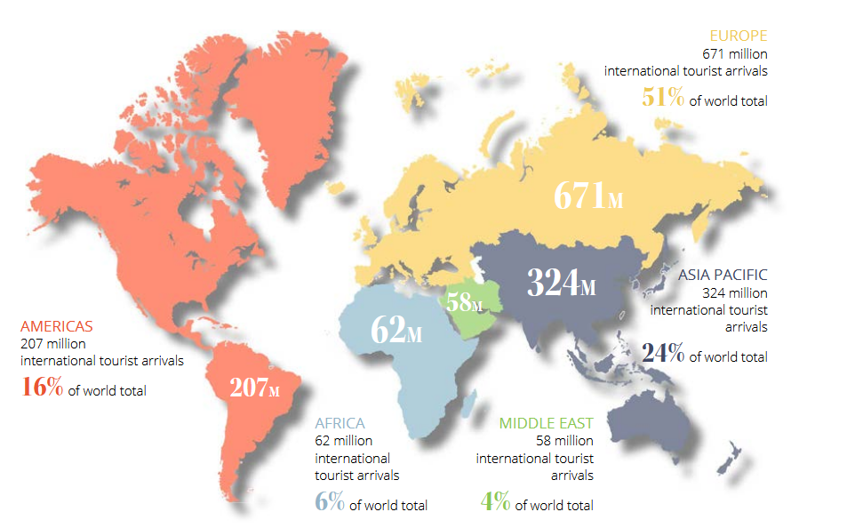
Figure nr. 1. International tourist arrivals in 2017

Source: "ICAO (2018)", Travel and Tourism a force for good in the world, accessed November 7, 2018,
https://www.icao.int/Meetings/iwaf2018/Documents/Travel%20and%20Tourism.pdf

By 2030, are estimates that there will be 1.8 international tourist arrivals - which means an average of 5 million people crossing international borders every single day. [ICAO, 2018]
As powerful as the travel and tourism sector is in terms of its reach and economic impact, it is unique in the diversity of its make up. Stakeholders in travel and tourism range from global hotel chains, cruise lines and seaports, and airports and airlines turning over billions of dollars every year, to individuals running a bed and breakfast, teaching a cooking class or leading a tour through their local community. Thinking of the industry in such a way allows us to picture not only the vast economic impact that it has at the global level, but also to consider the life-transforming effects it can have on real people in destinations across the world. [ICAO, 2018]
Looking to the next decade, 100 million new jobs could be created in the travel and tourism sector by 2028 - 64.5 million of these will be in the Asia Pacific region, with 35 million in China and 10 million in India. [ICAO, 2018]
The travel and tourism sector accounted for 10.4% of global GDP and 313 million jobs, or 1 in 10 jobs globally in 2017. With 4.6% GDP growth in 2017 - the highest rate since 2011 - the travel and tourism sector outperformed all other major global economic sectors, with manufacturing coming in second place with 4.2%, and financial services lagging behind with 2.5% industry sector growth. [ICAO, 2018]
With the right regulatory and policy environment, including support from governments, travel and tourism industry has the potential to create tens of millions of new jobs by 2028. [ICAO, 2018]

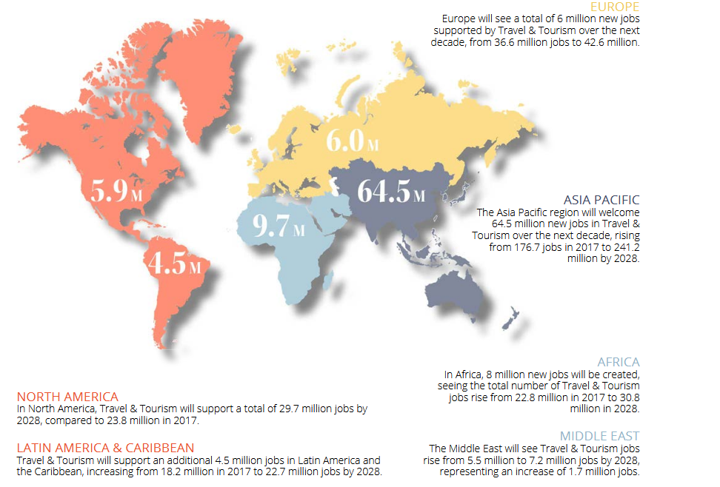
Figure nr. 2. Regional Breakdown of total job creation (millions) from 2017 to 2028

Source: "ICAO (2018)", Travel and Tourism a force for good in the world, accessed November 7, 2018,
https://www.icao.int/Meetings/iwaf2018/Documents/Travel%20and%20Tourism.pdf

The travel and tourism industry grew faster in 2017 than every other major economic sector, including financial services. [ICAO, 2018]
The USA received the greatest direct and total contribution to GDP from travel and tourism industry with $509.4 billion and $1501.9 billion respectively in 2017. China is forecast to overtake in both categories by 2028. [ICAO, 2018]
According to aviation, a new record 4.1 billion passengers were carried by the aviation industry on scheduled services in 2017, indicating a 7.1% increase over 2016. This figure is expected to almost double by 2036, with 7.8 billion people predicted to be travelling by air each year, 55% of international tourists travel to their destination by aircraft. [ICAO, 2018]
Cruise travel is on the rise, with 27.2 million passengers expected to set sail in 2018. In 2017, 25.8 million passengers cruised, representing 4.5% growth on 2016. [ICAO, 2018]
Overall growth in the cruise industry (64%) has exceeded that of the general global tourism sector (45%) over the past 10 years. [ICAO, 2018]
In 2017, the hotels and resorts industry generated $878 billion in revenue and employed 4.3 million people. [ICAO, 2018]
The travel and tourism industry directly contributed $2.6 trillion - equivalent to the size of the UK economy - to global GDP in 2017, or 3.2% of global GDP. [ICAO, 2018]
In 2017, travel and tourism industry's total (including directly, indirectly and induced impacts) contribution to global GDP was $8.3 trillion, equivalent to 10.4%.[ICAO, 2018]
International tourism receipts calculated as expenditure by international visitors on accommodation, food and drink, entertainment, shopping and other services and goods, amounted to $1.22 trillion in 2017. [ICAO, 2018]

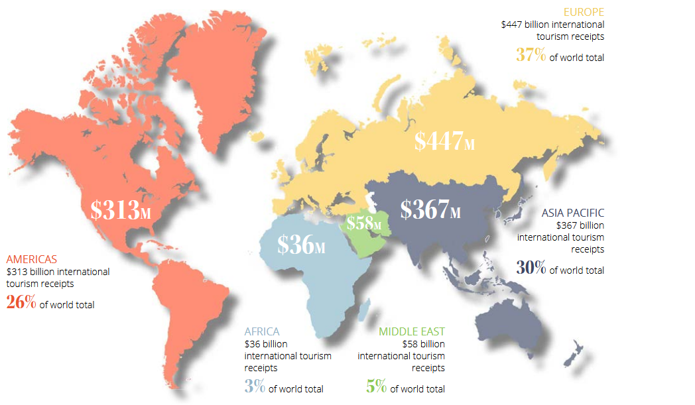
Figure nr. 3. International tourism receipts in 2017

Source: "ICAO (2018)", Travel and Tourism a force for good in the world, accessed November 7, 2018,
https://www.icao.int/Meetings/iwaf2018/Documents/Travel%20and%20Tourism.pdf

Travel and tourism industry is a major contributor to international trade in services, with global visitor exports, the amount contributed by visitors to the country they visit, generating a record $1.5 trillion in 2017. This is equivalent to an average of $4 billion a day, almost 7% of total exports and 30% of total world services exports. Global visitor exports should grow by 3.9% in 2018, and by 4.1% per year from 2018 to 2028 totalling $2.3 trillion in 2028, and making up 6.9% of total exports. [ICAO, 2018]
The travel and tourism industry yields significant economic and social benefits around the world, and possesses the power to change people's lives for the better by driving economic growth and development, reducing poverty through the provision of livelihoods, and fostering tolerance and peace through intercultural exchange and understanding. The sector has demonstrated strong and continued growth in the number of people travelling internationally each year, as well as its economic impact over the last six decades. Future predictions suggest that the sector will continue to grow in size and significance, amplifying its opportunity and responsibility to act as a force for good in the world. [ICAO, 2018]
While strong, sustained and diversified growth in travel and tourism industry is positive, high growth rates require all stakeholders at destinations to consider how to grow tourism responsibly and sustainably. Successful sustainable tourism strategies should move from promotion to broader destination planning and management, and look to the long-term to ensure quality engagement, preservation of natural and cultural resources, and the spread of tourism benefits to all. [ICAO, 2018]
The travel and tourism sector relies on the hotels and resorts industry to provide accommodation for people visiting new destinations, and the revenue this generates contributes to the sector as a whole. In 2017, the industry generated $878 billion globally in revenue, and employed 4.3 million people across 739,000 businesses. Over the past five years (to 2017), they estimate that the industry has grown at 3.2% per year, thanks to improved global economic conditions and the resulting boost to consumer confidence and increased travel. [ICAO, 2018]
Is estimates that the hotel industry comprises of 17.2 million rooms, and that branded hotels have 53% of the market. The leading branded hotel companies, including IHG, Marriott, Hilton, Wyndham and AccorHotels account for nearly one quarter of total open branded rooms and nearly 60% of the overall development pipeline. [ICAO, 2018]
In line with the travel and tourism sector as a whole, the hotels and resorts industry expects growth in the future thanks to improving global economic conditions resulting in higher GDP and more disposable income, as well as demographic shifts such as the growth of the middle class and an ageing population that has the desire and means to travel. [ICAO, 2018]
Travel and tourism industry and its related industries clearly contribute to the economic and social development of a nation, by driving economic growth, creating jobs and wealth, fostering trade and encouraging investment. The emergence of a tourism sector within a country offers the opportunity to acquire business or language skills thanks to newly realised entrepreneurial and other professional opportunities, resulting in human capital development, and upward social mobility. [ICAO, 2018]
The travel and tourism industry investment in 2017 was $882 billion, or 4.5% of total investment. It should rise by 4.8% in 2018, and rise by 4.3% pa over the next ten years to $1,408.3 billion in 2028 (5.1% of total). [World Travel and Tourism Council, 2018]
As the world becomes more connected and more focused on travel and tourism industry, innovative business models become crucial to the development of tourism. At the same time, particular attention must be paid to the challenges and threats that characterize the development and growth of the tourism industry.

New technology trends in the travel and tourism industry
The advent of technology is fostering a change in the travel and tourism industry regarding how companies interact with customers. Consequently, travel companies are adopting various technologies to improve operational efficiencies and meet customers’ expectations. [GlobalData, 2018]
The trends to watch out for in the travel and tourism industry in 2018 are[GlobalData, 2018]:
-Augmented and Virtual Reality (AR and VR): The past few years have seen an increase in AR or VR popularity among travel and tourism companies, and the trend is set to continue. These technologies are being used either for content marketing or to enhance the customers’ experiences. For example, airlines have started using VR technology to show travellers the cabins in advance, in order to increase ticket or ancillary services sales.
-Artificial Intelligence (AI): AI is behind many evolving technologies and innovations in the travel and tourism sector. The ways in which it helps the industry can be classified into three major categories: Machine Learning, ChatBots or TravelBots, and Robots. Thanks to AI, operations which usually require human intervention and a lot of time to learn new skills, can be automated, thus speeding up processes, while improving quality and performance, and decreasing costs.
-Internet of Things (IoT): IoT has a lot of potential to shape the future of the travel and tourism industry, and companies have started to realize that. An example of an industry player using IoT to reduce anxiety and stress levels associated with lost bags is Lufthansa. Passengers can track their baggage via a link found on their mobile boarding pass in the Lufthansa app.

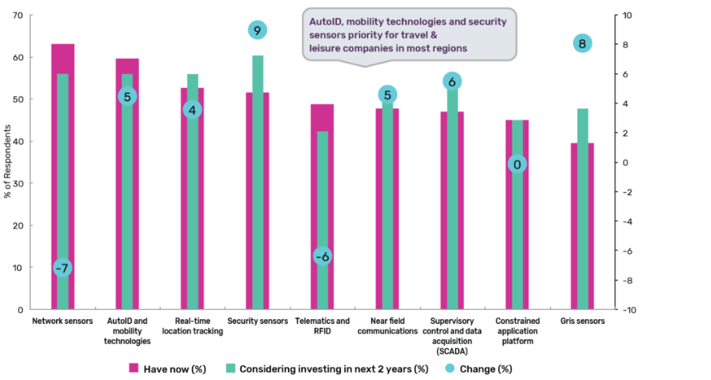
Figure nr. 4. Internet of Things solutions

Source: " GlobalData (2018)", Top 6 technology trends to watch out for in the travel and tourism industry in 2018, accessed November 8, 2018,https://www.globaldata.com/top-6-technology-trends-watch-travel-tourism-industry-2018/

-Voice Technology: Voice technology is another digital novelty that is beginning to disrupt the travel and tourism sector, as more and more customers switch from typed-in search to voice interactions. More and more hotels have started experimenting with voice-activated devices.
-Wi-Fi connectivity: When travelling, people want to always be connected, either to get destination ideas, options regarding places to visit or eat, find directions to points of interest, or share their experience with friends via social media or other connectivity platforms. As a result, investing in network services helps companies offer a more seamless and highly personalized experience to customers, boosts operational efficiency, real-time decision making, strengthens the physical (via CCTV) and the cybersecurity, along with data privacy.
-Wearable devices: Despite a sluggish start, travel and tourism companies are gradually using this technology to offer customers a more personalized and united experience. For instance, the Walt Disney Company deployed a wearable, customizable, RFID-equipped MagicBand, which connects to the theme park infrastructure, to reduce waiting times and track guests’ locations and activities.
Another is Blockchain, specifically crypto-currencies. This nascent technology, which allows for decentralized and secure storage and sharing of information, has the potential to increase trust while minimizing friction and corruption. [World Economic Forum, 2018]

The importance of visitors for travel and tourism industry
The importance of visitors are a value factor for travel and tourism industry, the number as increase in 2017, Bangkok was visited by 20 million tourist followed by London with 19.80 million and Paris with 17.50 million.

Table no. 1. Most visited destination in the world
Top 10 Most visited destination in the world

Destination in the world |  |  | Tourist number in 2017 | Growth forecast for 2018
1. |  | Bangkok | 20 million | 9.8%
2. |  | London | 19.80 million | 3.1%
3. |  | Paris | 17.50 million | 2.9%
4. |  | Dubai | 15.90 million | 5.5%
5. |  | Singapore | 13.90 million | 4.0%
6. |  | New York | 13.50 million | 4.1%
7. | Kuala Lumpur |  | 12.50 million | 7.5%
8. | Tokyo |  | 11.90 million | 1.6%
9. | Istanbul |  | 10.50 million | 19.5%
10. | Seoul |  | 9.50 million | 6.0%
Source: personal contribution

In 2018, are estimated to grow with 19.5% in Istanbul followed by Bangkok with 9.8% and Kuala Lumpur with 7.5%.
In other words, there are so many interesting and beautiful places to discover in the world. Some countries have a larger tourism industry than others, but just about all of them have something to offer.
In 2018, the following countries are among the most visited in the world:
1.France with 82.6 million visitors. The most visited places in France are following:
-Eiffel tower in Paris - the most visited city in France.
-St Tropez summer holiday destination.
-Chamonix ski resort.
-Palace of Versailles.
-Mont Saint-Michel.
2. The United States with 75.6 million visitors. Most visited places in the USA are:
-Manhattan in NYC.
-Grand Canyon.
-Yellowstone National Park with its geysers.
-Golden Gate Bridge in San Francisco.
-Niagara Falls at the borders with Canada.
3. Spain with 75.6 million visitors. Most visited places in Spain are:
-Sagrada Familia in Barcelona.
-Alhambra.
-Mezquita of Cordoba.
-El Escorial.
-Ibiza island.
4. China with 59.3 million visitors. Most visited places in China are:
-The Great Wall of China in Beijing.
-The Terracotta Army in Xi’an.
-The Forbidden City in Beijing.
-The Li River in Guilin.
-The Yellow Mountains in Huangshan.
5. Italy with 52.4 million visitors. Most visited places in Italy are:
-Grand Canal in Venice.
-Colosseum in Rome.
-Florence Cathedral.
-Piazza del Campo in Siena.
-Pompeii.
6. United Kingdom with 35.8 million visitors. Most visited places in the UK are:
-London.
-Scottish Highlands.
-Stonehenge.
-Edinburgh.
-York.
7. Germany with 35.6 million visitors. Most visited places in Germany are:
-Berlin’s Brandenburg Gate.
-Cologne Cathedral.
-The Black Forest.
-Neuschwanstein Castle.
-Miniatur Wunderland.
8. Mexico with 35.0 million visitors. Most visited places in Mexico are:
-Teotihuacán and it’s huge pyramids.
-Chichen Itza – the largest of the Maya cities in the Yucatan Peninsula.
-Tulum – for those looking for ideal beach holidays.
-Copper Canyon – a network of canyons.
-Palenque – an archaeological site.
9. Thailand with 32.6 million visitors. Most visited places in Thailand are:
-Ko Phi Phi.
-Phang Nga Bay.
-Grand Palace, Bangkok.
-Rai Leh.
-Mu Ko Chang National Park.
10. Turkey with 30 million visitors. Most visited places in Turkey are:
-Istanbul.
-Antalya.
-Cappadocia.
-Bodrum.
-Side.

Table no. 2. Most visited countries in the world
Top 10 Most visited countries in the world
1. |  | France | 82.6 million visitors
2. |  | The United States | 75.6 million visitors
3. |  | Spain | 75.2 million visitors
4. |  | China | 59.3 million visitors
5. |  | Italy | 52.4 million visitors
6. |  | United Kingdom | 35.8 million visitors
7. | Germany |  | 35.6 million visitors
8. | Mexico |  | 35.0 million visitors
9. | Thailand |  | 32.6 million visitors
10. | Turkey |  | 30 million visitors
Source: personal contribution

Other countries with many visitors in 2018, are Greece with 24.8 millions, Japan with 24.0 millions, Canada with 20.0 millions or Singapore with 12.9 millions.
The biggest risks in the travel and tourism industry at global level are related to geopolitics, terrorism, uncontrolled spread of epidemics, data sharing and security. These risks can have severe repercussions on the tourism industry, whose development depends directly on providing a safe travel experience. Security-related events have had a strong impact on the affected tourist destinations and have been particularly affected by the decrease in the number of tourists and the drastic decrease in revenues from this economic activity. Thus, it focuses on identifying innovations, technological and infrastructure development at local, regional, national level to facilitate travel conditions with improved security measures.

Conclusions
In conclusion, the travel and tourism industry are very important for most countries in the world, having a prime place in the economy due to the high income it brings. Tourism development policies in the world are increasingly important for developing countries. Not only have they introduced a new sector into the country's economy, they have achieved macroeconomic objectives. That is why most countries concentrate their efforts on attracting foreign tourists, in order to increase the country's foreign reserves.
Tourism has a special importance in meeting the material and spiritual needs of the people. It contributes to restoring the body through rest, recreation, movement, balneo-medical treatments, manifests itself as a means of educating people, favors the exchange of ideas, the knowledge of tourists and the local population.
Tourism also has influences on the environment and its components, both positive and negative, and tourists must learn to protect the environment. At the same time, it acts in the direction of enhancing ties between nations, knowing people and peoples and helping to maintain peace in the world.
More and more tourists begin to look for vacations as more than just a break in the office. A journey means opening the mind and gaining new experiences. That's why the number of tourists who want to travel to exotic places is simply growing, just different from what they are accustomed to seeing in the areas where they live and want to see more.
In this case, the new trends in the travel and tourism industry are:
- Responsible and sustainable tourism.
- Wellness tourism.
- Millennial travelers.
- Family holidays.
- Adventure holidays.
- Food tourism.
- To travel single.

References
1. GlobalData (2018), Top 6 technology trends to watch out for in the travel and tourism industry in 2018, accessed November 8, 2018,
https://www.globaldata.com/top-6-technology-trends-watch-travel-tourism-industry-2018/
2. ICAO (2018), Travel and Tourism a force for good in the world, accessed November 7, 2018,
https://www.icao.int/Meetings/iwaf2018/Documents/Travel%20and%20Tourism.pdf
3. World Economic Forum (2018), These three technology trends will change the way you travel, accessed November 10, 2018,
https://www.weforum.org/agenda/2018/06/three-technology-trends-changing-travel-tourism/
4. World Travel and Tourism Council (2018), Economic Impact 2018 World, accessed November 9, 2018,
https://www.wttc.org/-/media/files/reports/economic-impact-research/regions 2018/world2018.pdf

