IMPACT OF SUSTAINABLE TOURISM IN THE TRAVEL INDUSTRY

Bogdan SOFRONOV¹
¹University Politehnica of Bucharest, Splaiul Independenței 313, Bucharest 060042, Romania
Email: bogdansofronov@yahoo.com

Abstract
Sustainable tourism is the concept of visiting a place as a tourist and trying to make only a positive impact on the environment, society and economy. A key aspect is respect for the people who call the location home, the culture and customs of the area, and the socio-economic system. While sustainable tourism is sometimes confused with ecotourism, ecotourism is actually only one aspect of sustainable tourism.
Sustainable tourism is attempting to have a low impact on the environment and local culture, while helping to generate future employment for local people. The aim of sustainable tourism is to ensure that development brings a positive experience for local people, tourism companies and the tourists themselves.

Key words: sustainable impact; sustainable tourism; tourism; travel industry; sustainability.
JEL Classification: Z30, Z32

Introduction
In introduction sustainable tourism is defined like development of all forms of tourism, tourism management and marketing that respect the natural, social and economic integrity of the environment, ensuring the exploitation of natural and cultural resources and future generations.
The sustainable tourism are covers all forms and activities in the hospitality industry, including conventional table tourism, cultural tourism, business tourism, rural tourism, cruise tourism, religious tourism and sports tourism, urban tourism. The sustainability process should normally be coordinated at national level by governmental stakeholders and supported by local stakeholders at community level.
The sustainability in tourism has the following independent aspects: environmental, social-cultural and economical. Sustainable development implies sustainability, which means that sustainable tourism requires optimal use of resources, minimizing economic, socio-cultural and ecological negative impacts, maximizing benefits for local communities, national economies, and preserving nature. As a natural consequence, sustainability also refers to the managerial structures needed to meet these desires.
In my opinion, the goal of sustainable tourism must be subordinated to national and regional economic and social development plans. Actions can cover economic goals, social goals, poverty alleviation and inequality in income distribution, the protection of indigenous socio-cultural heritage, participation and involvement of local communities, or ecological goals to protect the functions of ecotourism, the conservation and sustainable use of biodiversity. Some specialists prefer to talk about the sustainable development of tourism rather than sustainable tourism, the first referring to all aspects of development, and the second to some aspects and components of tourism - such as long-distance air transport that can purely and simply not be sustainable under current technology, even with the use of best practices.
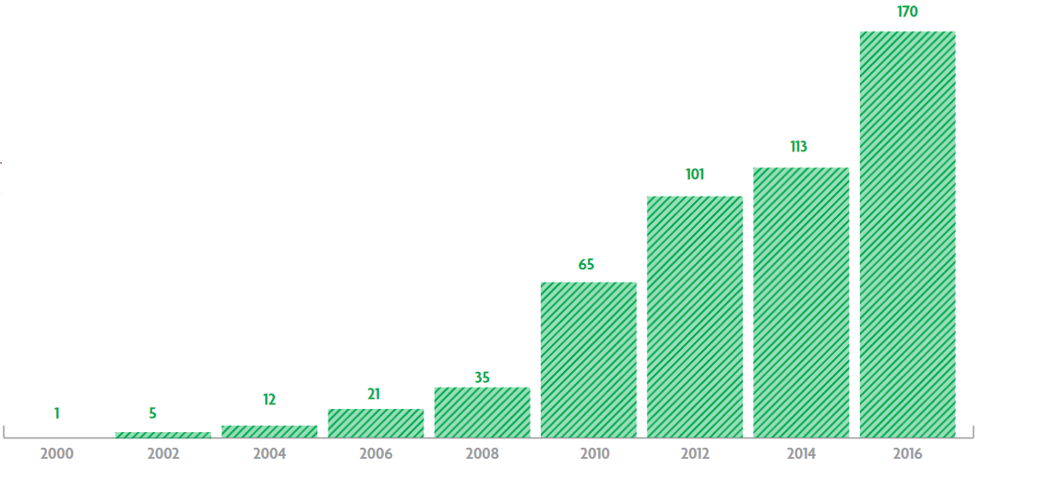
Figure nr. 1. Sustainability Reporting within Tourism
Source: " Sustainability reporting in Travel and Tourism (2017)," World Travel & Tourism Council, accessed October 31, 2017, https://www.wttc.org/-/media/files/reports/policy-research/esg-2017/esg-2017-sustainability-reporting-in-travel-and-tourism.pdf

Literature Review
My research paper entitled: Impact of sustainable tourism in the travel industry, is written after I've documented on the basis of the following published articles:
1. Sustainable tourism research: an analysis of papers written by Jiaying Lu and Sanjay K. Nepal published on Journal of Sustainable Tourism.
2. Sustainable tourism: A state-of-the-art review written by Richard W. Butler published on International Journal of Tourism Space, Place and Environment.
3. Romanian Tourism Marketing Researches written by Viorica Jelev published on Annals of Spiru Haret University. Economic Series.

Key challenges for more sustainable tourism
Promoting sustainable tourism is essential, especially in the regions of the world that have experienced the fastest rate of global warming. Therefore, the management of water resources, pollution and waste and the fight against soil erosion are among the major challenges of tourism.
Promoting sustainable tourism requires the reduction of foreign visitors' culture as much as possible, as well as the prevention of excessive marketing of local culture. It is vital that sustainable tourism allows the preservation of traditions and not affect the rich diversity of the region.
Starting from the key points of sustainable sustainable tourism development, the impact of tourism activities implies the following:
-increasing the viability of some localities with reduced natural resources;
-the use of poorly productive agricultural land, by developing appropriate tourism facilities;
-increasing the incomes of the inhabitants in the conditions of the reduction of grazing and exploitation forestry;
-increasing the economic power of the localities, by obtaining new revenues from new taxes and taxes local;
-encourage traditional activities, especially those of artisanal and small industry traditional;
-developing a specific trade based on local economic and crafts products;
-the incomes obtained from the tourism and the specific trade of this framework, can contribute to the support of actions for modernization of the cultural objectives, ecological restoration of the valuable landscapes;
-the profit and earnings port - as a result of the reception, hosting, transport and public catering activities, will be an important contribution to the local development plan.

To have a more sustainable tourism, we need to[Sustainable Tourism, 2017]:

-Is important to use biodegradable products for washing, cleaning, to protecting local water sources.
-Use only sustainable products to build hotels and ensure the woods are from sustainable forests.
-Collect rainwater and recycle the water. This possible in tropical climates, where there is a large amount of water.
-Set quotas to limit the amount of tourists visiting an area. Establish a carrying capacity and stick to it.
-Creating National parks and reserves to protect local flora and fauna
-Creating breeding programs for endangered species e.g. the Amur Leopard or the Panda.
-Use renewable energy to power tourist facilities e.g. solar or wind.
-Use local food products to reduce food miles
-Transport guests use public transport or low emission vehicles.
To make Tourism Economically Sustainable we need to[Sustainable Tourism, 2017]:
- Is very important to ensure as much money as possible stays inside the host country then minimise economic leakage. Profits from many companies go overseas.. This can be a difficult balancing act, because you don't want to stop FDI.
-Employing only the local residents in tourist facilities. Train local staff so that they are able to work in managerial roles as well as manual roles. These skills can then become transferable to different local industries.
-Be locally owned. This is not always possible, especially if FDI is needed to establish a tourism resort or project, but local staff and products should definitely be used.
-Only purchasing local products
-Avoid debt when building tourist developments.
The Sustainable Tourism in Urban Areas[Sustainable Tourism, 2017]:
-Promote local hotels and shops
-Reduce electricity and water waste by educating tourists
-Ensure locals can also afford to visit nationally visit historic sites. Many countries run dual pricing, where tourists pay more than locals to visit sites.
-Recycling Bins
-Enforced fines for littering
-Pedestrianised areas
-Cheap public transport
-Bike hire
-Possible introduce quotas or curfews to protect areas.
-Ensure locals are not priced out of local market - try and maintain traditional mix of residents, tourists, businesses, etc.
The Sustainable Tourism in Coastal Environments[Sustainable Tourism, 2017]:
-Is important to avoid sewage being pumped into the sea
-Banning of plastic bags very harmful to turtles who mistake them for jellyfish
-Avoid light pollution near turtle nesting sites. Baby turtles are often confused by light and struggle to find the sea (normally they use the light from the horizon)
-Promote sustainable diving (possible introduce quotas like in Sipadan in Malaysia)
-Avoid privatisation of beaches. Ensure that locals can also use the beach
-Stop trade in coral, turtles shells, etc.
-Ensure that seafood is caught from sustainable sources. In Japan, sustainable sushi is being introduced to protect blue fin tuna, whales, etc.
-Minimise damage to mangroves, dunes, forests, etc. when building resorts.
-Ensure proper boating channels to avoid injury and death to turtles, manatees, etc. from speed boats and jet skis.
The Sustainable Tourism in National Parks[Sustainable Tourism, 2017]:
-Is important to create National Parks to protect flora and fauna
-Reforest areas that have been damaged or logged
-Ensure that no illegal logging takes place
-Stop poaching (catching wild animals) by making it illegal and enforcing with strong penalties.
-Only allow low impact activities e.g. walking, horse riding.
-Start breeding and reintroduction programmes e.g. the giant panda in China.
-Only allow small scale developments using locals products to build the small-scale low-impact developments e.g. basic cabins or just tents
-Use renewable energy sources e.g. local HEP
-Ensure no non-biodegradable products are released into local water sources or the ground.
-Educate tourists about flora and fauna and the importance of protection.

Impact of sustainable tourism in the travel industry
The tourism industry is responsible for about 5.3% of total greenhouse gas emissions, 75% of which is generated by transport, which is the main source of air pollution related to tourism. Therefore, it is important to promote clean or less energy-efficient modes of transport.
The air transport is by far the most polluting means of transport, but public administration itself often promotes it against rail transport. Every year there has been an annual 5-6% increase in the number of flights, especially as a result of the significant reduction in ticket prices.
Sustainable tourism has the following principles:
-the tourist activity must be initiated with the own means of the local community, and it must maintain its control over the tourism development;
-tourism must provide jobs to residents to improve the quality of life of local communities and a balance must be struck between the economic activities already existing in the area and the tourism activity;
-has a code of practice for tourism must be established at all levels: national, regional andlocal, based on already accepted international standards. The guidelines for tourism operators, the monitoring of the impact of different tourist activities and the acceptability limits for different areas can also be established;
- educational and training programs are needed to improve management in the field of natural and cultural resources protection.
So, the sustainable tourism development is not only a concept debated, completed or reformulated in the conferences held on this topic. The need to protect the natural, social and cultural richness that constitutes the common heritage of humanity and the satisfaction of the needs of the tourists and the local population has led to the emergence of sustainable forms of tourism. The objectives, principles and requirements of sustainable tourism development are found in forms of tourism such as ecotourism, rural tourism or cultural tourism. These forms are the expression of the desire that tourism represents not only a positive and dynamic development factor and a practical solution of unaltered preservation of the environment.
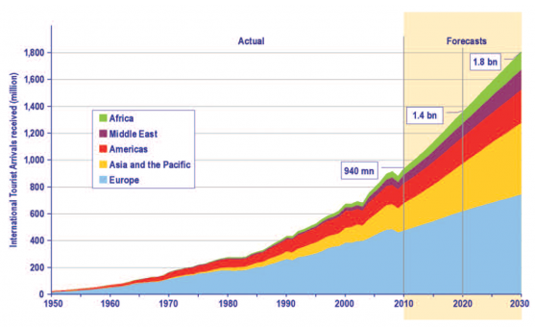
Figure nr. 2. UNWTO Tourism Towards 2030: Actual trend and forecast 1950-2030
Source: "Gaval, I (October 6, 2016)", The economic benefits of Sustainable Tourism, accessed October 31, 2017, https://ecobnb.com/blog/2016/10/economic-benefits-sustainable-tourism/

Critical Issues for the Future of Sustainable Tourism
The developing of sustainable tourism through its practical forms, reconciling antagonistic interests and objectives, fostering partnership and cooperation among decision-makers, operators and consumers and promoting long-term general interest.
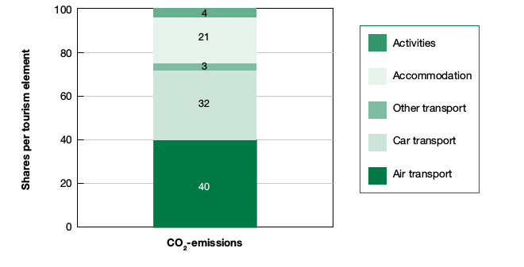
Figure nr. 3. Contribution of various tourism sub-sectors to CO2 emissions (%)
Source: "Gaval, I (October 6, 2016)", The economic benefits of Sustainable Tourism, accessed October 31, 2017, https://ecobnb.com/blog/2016/10/economic-benefits-sustainable-tourism/

The tourism industry attaches a greater importance to environmental issues and increasing attention to sustainable tourism, the differences between good intentions expressed by people when undergoing research and what they will actually do on holidays should not be underestimated. There is no doubt that tourism, if well-planned and driven, can generate income for the local population and speed up the development of the region. It has become a major source for many countries and many countries around the world. World, cultural and natural heritage, for example, attracts visitors from all over the world and can become the engine of local development. But more attention should be paid to the physical and cultural impact of mass tourism, including indirect losses occurring where overcrowding occurs.
The future of sustainable development depends on the restructuring of the global economy and requires major changes in human behavior, value system and lifestyle. We can no longer claim that tourism is one of the best ways to achieve local sustainable development when it is rather the bitter-bitter antidote of sustainable development from anywhere. World, cultural and natural world should be used as best to sensitize people in terms of the importance of building links between nature and culture, between different cultures.
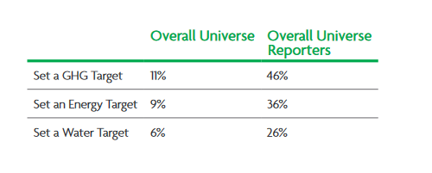
Figure nr. 4. Prevalence of Energy, Water, Waste, and Carbon Targets in Travel & Tourism
Source: " Sustainability reporting in Travel and Tourism (2017)," World Travel & Tourism Council, accessed October 31, 2017, https://www.wttc.org/-/media/files/reports/policy-research/esg-2017/esg-2017-sustainability-reporting-in-travel-and-tourism.pdf

Conclusions
In conclusion the sustainability and competitiveness of the tourism industry go hand-in-hand as the quality of tourist destinations is strongly influenced by their natural and cultural environment, and their integration into the local community. [Sustainable Tourism, EC, 2017]
Sustainability in tourism on long-term requires a balance between economic, socio-cultural, and environmental sustainability. The need to reconcile economic growth and sustainable development also has an ethical dimension. [Sustainable Tourism, EC, 2017]
The most significant challenges for sustainable tourism are[Sustainable Tourism, EC, 2017]:
-to improving the quality of tourism jobs;
-to preserving natural and cultural resources;
-limiting negative impacts at tourist destinations, including the use of natural resources and waste production;
-promoting the wellbeing of the local community;
-reducing the seasonality of demand;
-limiting the environmental impact of tourism-related transport;
-to make tourism accessible to all.
The development of sustainable tourism is based on the following:
- setting ecological limits, consumption standards and norms, reducing unjustified consumption;
- redistribution of economic activity and reallocation of resources, satisfaction of the essential needs of life, and at the same time economic growth;
- providing a optimal population, the demographic increase being in line with the potential of the exploitable ecosystems;
- conservation of basic resources and preservation of natural areas that support the genetic patrimony of flora and fauna;
- legal access to resources, increased technological effort and rational use;
- the establishment of a minimum rate of exploitation and resource consumption;
-community control, the role of the local community in the decision-making of local development;
- ensuring the management of all resources that emphasize quality.
The positive aspects of sustainable tourism are:
- to increase the social and professional chances by creating new jobs, tourist services and general infrastructure;
- create new seasonal jobs, especially for young people and women;
-developing and ensuring social progress, increasing the cleanliness and public hygiene, general comfort in the tourist localities;
- the fall in the differences between socio-professional categories in terms of income;
-developing feelings of understanding and tolerance because intercultural exchanges between tourists and the host population facilitate the disappearance of linguistic, social, racial, religious, cultural barriers.

References
1. Gaval, I (October 6, 2016), Retrieved from https://ecobnb.com/blog/2016/10/economic-benefits-sustainable-tourism/
2. Sustainability reporting in Travel and Tourism, (October, 2017), Retrieved from https://www.wttc.org/-/media/files/reports/policy-research/esg-2017/esg-2017-sustainability-reporting-in-travel-and-tourism.pdf
3. Sustainable Tourism (2017), Accessed November 1, 2017 http://greenfieldgeography.wikispaces.com/Sustainable+tourism
4. Sustainable Tourism, European Commission (2017), Accessed November 1, 2017 https://ec.europa.eu/growth/sectors/tourism/offer/sustainable_en

