IMPACT OF SUSTAINABLE TOURISM IN THE TRAVEL INDUSTRY

Bogdan SOFRONOV¹
¹University Politehnica of Bucharest, Splaiul Independenței 313, Bucharest 060042, Romania
Email: bogdansofronov@yahoo.com

Abstract
Sustainable tourism is the concept of visiting a place as a tourist and trying to make only a positive impact on the environment, society and economy. A key aspect is respect for the people who call the location home, the culture and customs of the area, and the socio-economic system. While sustainable tourism is sometimes confused with ecotourism, ecotourism is actually only one aspect of sustainable tourism.
Sustainable tourism is attempting to have a low impact on the environment and local culture, while helping to generate future employment for local people. The aim of sustainable tourism is to ensure that development brings a positive experience for local people, tourism companies and the tourists themselves.

Key words: sustainable impact; sustainable tourism; tourism; travel industry; sustainability.
JEL Classification: Z30, Z32

Introduction
In introduction sustainable tourism is defined like a positive phenomenon that has been going on for some time, but in recent years it has been gaining more traction with millennials. The idea behind sustainable tourism is that the travel industry should be part of helping build up the local communities, be part of the culture, and support the people that the industry comes in contact with, instead of merely descending on them. [How Sustainable Tourism is impacting the Travel Industry, 2016]
Tourist industry and travel can work together, such that sustainable tourism can be a benefit in multiple ways to the places that tourists go to, instead of merely taking from them for capitalistic reasons, to allows tourists and the tourism industry to be able to give back to the very communities that they visit, so this idea of giving something back on a trip that has become very appealing to a new generation of sustainable tourists. [How Sustainable Tourism is impacting the Travel Industry, 2016]
The tourism industry has keep up with the global trend of increased sustainability reporting and use of Environmental, Social and Governance (ESG) information. Stock exchange regulations, government reporting mandates, customer requests, and internal recognition of its importance have all contributed to this trend. Likewise, enhancements such as aligning with the UN Sustainable Development Goals (SDGs), setting bold goals, and evolving reporting formats are found anecdotally among a handful of tourism businesses that have a longer history of reporting. [Sustainability reporting in Travel and Tourism, 2017]
The reporting in sustainable tourism has an considerable uptake in recent years. Reporting is common but not necessarily mainstream. Among the universe of potential reporters through 2016, Tourism had an increase of reporters of 50%, despite the overall universe of potential reporters only growing by 4%. Among the similar universe of 568 companies for the last three years (like-for-like), reporting has increased by 45% since 2014. [Sustainability reporting in Travel and Tourism, 2017]
Tour operators and travel agencies report the least, with only 16% of the universe reporting through 2016. Airlines continue to report the most, with 35% of the universe reporting. [Sustainability reporting in Travel and Tourism, 2017]
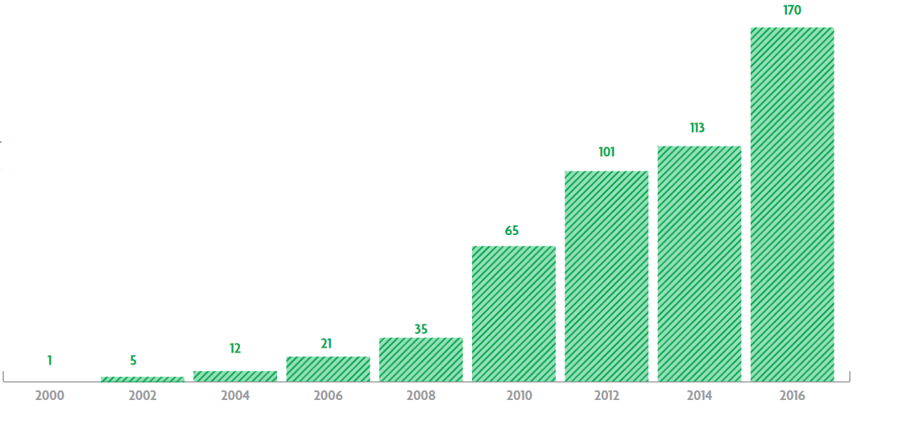
Figure nr. 1. Sustainability Reporting within Tourism
Source: " Sustainability reporting in Travel and Tourism (2017)," World Travel & Tourism Council, accessed October 31, 2017, https://www.wttc.org/-/media/files/reports/policy-research/esg-2017/esg-2017-sustainability-reporting-in-travel-and-tourism.pdf

Literature Review
My research paper entitled: Impact of sustainable tourism in the travel industry, is written after I've documented on the basis of the following published articles:
1. Sustainable tourism research: an analysis of papers written by Jiaying Lu and Sanjay K. Nepal published on Journal of Sustainable Tourism.
2. Sustainable tourism: A state-of-the-art review written by Richard W. Butler published on International Journal of Tourism Space, Place and Environment.
3. Romanian Tourism Marketing Researches written by Viorica Jelev published on Annals of Spiru Haret University. Economic Series.

Key challenges for more sustainable tourism

To have a more sustainable tourism, we need to[Sustainable Tourism, 2017]:

-Is important to use biodegradable products for washing, cleaning, to protecting local water sources.
-Use only sustainable products to build hotels and ensure the woods are from sustainable forests.
-Collect rainwater and recycle the water . This possible in tropical climates, where there is a large amount of water.
-Set quotas to limit the amount of tourists visiting an area. Establish a carrying capacity and stick to it.
-Creating National parks and reserves to protect local flora and fauna
-Creating breeding programs for endangered species e.g. the Amur Leopard or the Panda.
-Use renewable energy to power tourist facilities e.g. solar or wind.
-Use local food products to reduce food miles
-Transport guests use public transport or low emission vehicles.
To make Tourism Economically Sustainable we need to[Sustainable Tourism, 2017]:
- Is very important to ensure as much money as possible stays inside the host country then minimise economic leakage. Profits from many companies go overseas.. This can be a difficult balancing act, because you don't want to stop FDI.
-Employing only the local residents in tourist facilities. Train local staff so that they are able to work in managerial roles as well as manual roles. These skills can then become transferable to different local industries.
-Be locally owned. This is not always possible, especially if FDI is needed to establish a tourism resort or project, but local staff and products should definitely be used.
-Only purchasing local products
-Avoid debt when building tourist developments.
The Sustainable Tourism in Urban Areas[Sustainable Tourism, 2017]:
-Promote local hotels and shops
-Reduce electricity and water waste by educating tourists
-Ensure locals can also afford to visit nationally visit historic sites. Many countries run dual pricing, where tourists pay more than locals to visit sites.
-Recycling Bins
-Enforced fines for littering
-Pedestrianised areas
-Cheap public transport
-Bike hire
-Possible introduce quotas or curfews to protect areas.
-Ensure locals are not priced out of local market - try and maintain traditional mix of residents, tourists, businesses, etc.
The Sustainable Tourism in Coastal Environments[Sustainable Tourism, 2017]:
-Is important to avoid sewage being pumped into the sea
-Banning of plastic bags very harmful to turtles who mistake them for jellyfish
-Avoid light pollution near turtle nesting sites. Baby turtles are often confused by light and struggle to find the sea (normally they use the light from the horizon)
-Promote sustainable diving (possible introduce quotas like in Sipadan in Malaysia)
-Avoid privatisation of beaches. Ensure that locals can also use the beach
-Stop trade in coral, turtles shells, etc.
-Ensure that seafood is caught from sustainable sources. In Japan, sustainable sushi is being introduced to protect blue fin tuna, whales, etc.
-Minimise damage to mangroves, dunes, forests, etc. when building resorts.
-Ensure proper boating channels to avoid injury and death to turtles, manatees, etc. from speed boats and jet skis.
The Sustainable Tourism in National Parks[Sustainable Tourism, 2017]:
-Is important to create National Parks to protect flora and fauna
-Reforest areas that have been damaged or logged
-Ensure that no illegal logging takes place
-Stop poaching (catching wild animals) by making it illegal and enforcing with strong penalties.
-Only allow low impact activities e.g. walking, horse riding.
-Start breeding and reintroduction programmes e.g. the giant panda in China.
-Only allow small scale developments using locals products to build the small-scale low-impact developments e.g. basic cabins or just tents
-Use renewable energy sources e.g. local HEP
-Ensure no non-biodegradable products are released into local water sources or the ground.
-Educate tourists about flora and fauna and the importance of protection.
-Give flora and fauna and economic value, making animals more valuable a live than dead. In Rwanda tourists now pay $500 to see mountain gorillas. This has completely stopped poaching because the mountain gorillas are now more valuable alive than dead.

Impact of sustainable tourism in the travel industry
The Sustainable Tourism is very important for the planet and its future and brings econonomic advantages. The UN has dedicated the year 2017 the International Year of Sustainable Tourism. Let’s find out what are the benefits of sustainable tourism which are not only environmental and social, but also economic. [Gaval, 2016]
The tourism industry is the third economic activity in Europe and contributing 80% of GDP and 12% of employment creation, according to data from EU. Every year a billion people travel throughout the world (one in nearly six people) and continue to grow. The forecast maintain that, in 2030, the number of tourists will increase to 1.8 million, doubling the number of a few years ago. [Gaval, 2016]
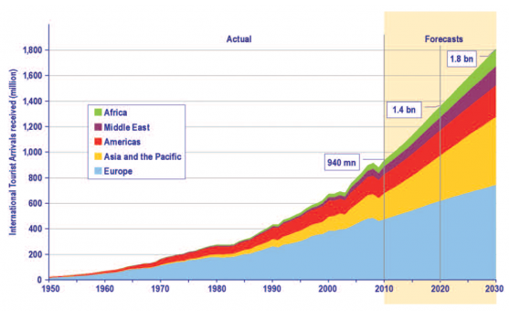
Figure nr. 2. UNWTO Tourism Towards 2030: Actual trend and forecast 1950-2030
Source: "Gaval, I (October 6, 2016)", The economic benefits of Sustainable Tourism, accessed October 31, 2017, https://ecobnb.com/blog/2016/10/economic-benefits-sustainable-tourism/

The importance and the future of sustainable tourism is a valuable economic tool for people in the travel industry to understand that this is the way of the future. More and more young people are designing these types of trips, so learning how to cater trips that involve social impact travel will be critical to maintaining and fulfilling the desires of the young traveling millennial generation. [How Sustainable Tourism is impacting the Travel Industry, 2016]
The sustainable tourism importance in the travel industry it's difficult to be understated, so the importance of both the money and the manpower that millennials and others bring to bear on many different social issues is only going to continue to grow as the years go on. With two billion dollars already going into the sustainable tourism industry, it is likely to become one of the single hottest trends for the millennial vacationer. Vacations with meaning are leading to a greater desire for social impact travel. [How Sustainable Tourism is impacting the Travel Industry, 2016]
Is a new generation of sustainable tourists is being led by the millennials, they are far more likely than any other tourist demographic to be interested in giving back to the areas they go to. A lot of this comes from a strong sense of civic responsibility, the desire to help other people live better lives, and also a desire to have a meaningful impact. For many millennials, tourism is simply not a way to get away from life – it is a way to embrace life. It is a way to add to the quality of their life and for many of them, that quality of life can be enhanced dramatically by helping other less fortunate people or by making a difference in an area of the world. [How Sustainable Tourism is impacting the Travel Industry, 2016]
Traveling is for millennials a chance for them to grow as people, a concept called transformational travel. This is truly a chance for them to feel like they’re making a difference in the world. So to a millennial, sustainable tourism is one of the most attractive types on the market today. Sustainable tourism provides a way for them to be able to experience enriching content as well as allowing them to do things that they believe will have a long-term positive impact wherever they have gone. All of this binds together to help provide that enriching cultural experience as well. [How Sustainable Tourism is impacting the Travel Industry, 2016]
The goal of pro-poor tourism is to have positively impact the most destitute and needy by bringing in tourist dollars as well as skill and experience to those areas in the world most in need.Pro-poor tourism is defined liked a kind of tourism where instead of people going on vacation, they seek instead to go to areas of the world that are most in need of assistance, like poverty-stricken areas where people are in need of food, medicine, or other necessities of life as part of a cultural enrichment experience in their transformational travel.The pro-poor tourism, is an outgrowth of sustainable tourism in the travel industry [How Sustainable Tourism is impacting the Travel Industry, 2016]
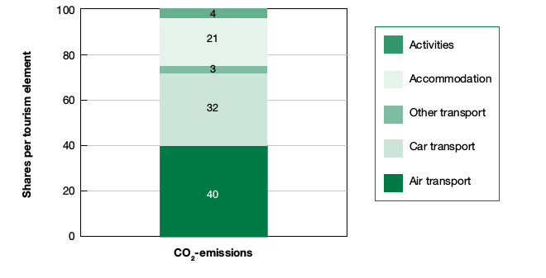
Figure nr. 3. Contribution of various tourism sub-sectors to CO2 emissions (%)
Source: "Gaval, I (October 6, 2016)", The economic benefits of Sustainable Tourism, accessed October 31, 2017, https://ecobnb.com/blog/2016/10/economic-benefits-sustainable-tourism/

The tourism industry represents one of the biggest economy sectors in the world, which makes it an important growth opportunity for the least developed countries. On the other hand, tourism is one of the major causes of pollution and carbon dioxide production. For example, EU data tells us that tourism is one of the first causes of the carbon dioxide production in Europe, and that over 20% of polluting emissions are associated with accommodations. Then the growing awareness of the issue of environmental limits of the tourism development is leading us to experiment alternative methods of tourism and accommodations that are environmentally safe and benefit places and local economies. [Gaval, 2016]
The sustainable tourism is increasing, and the sustainability in tourism is no longer just a trend, it’s a lifestyle. Awareness is increasing of environmental and climatic problems in the same way that knowledge grows of how much each one of us could contribute to solutions to global problems by modifying our way of life. [Gaval, 2016]

Critical Issues for the Future of Sustainable Tourism
The tourism industry has direct contribution to degradation in environmentally sensitive areas such as coral reefs, nature reserves, and coastal regions. This can include waste and pollution at resorts, hotel expansion damaging local habitats, and insufficient marine protection measures causing damages to reefs. The risk to business is to maintain the quality of the destination, but also reputation and license to operate, to manage a responsible supply chain, and being prepared to respond to regulation if operations are seen to be detrimental. [Sustainability reporting in Travel and Tourism, 2017]
The climate change has the impact on the attractiveness and long-term feasibility of certain destinations. The largest component of global tourism, coastal destinations are particularly at risk from rising sea levels, flooding, hurricanes, storms, and acidification caused by climate change. Winter sport destinations are also affected by deterioration of snow conditions as a result of increased temperatures, and desertification is affecting arid areas. The risk to business comes from different consumer demands and the viability of operations. Additionally, travelers may increasingly opt for different destinations, rendering some tourism infrastructure at previously popular locations unused assets.[Sustainability reporting in Travel and Tourism, 2017]
In tourism industry the most notable thing is the use of intensity-based reduction targets, rather than absolute reduction targets. Absolute reductions, are outright based on aggregate output. Intensity-based reduction targets are based on a reduction per a unit of production, such as square footage, passengers, visitors, room nights, employees, or revenue dollars. Within benchmarked companies, absolute reduction targets in carbon, energy, water, or waste were found in only a handful of companies. [Sustainability reporting in Travel and Tourism, 2017]
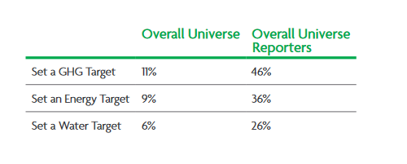
Figure nr. 4. Prevalence of Energy, Water, Waste, and Carbon Targets in Travel & Tourism
Source: " Sustainability reporting in Travel and Tourism (2017)," World Travel & Tourism Council, accessed October 31, 2017, https://www.wttc.org/-/media/files/reports/policy-research/esg-2017/esg-2017-sustainability-reporting-in-travel-and-tourism.pdf

The tourism industry is expected to grow in contribution to the global economy from 10.2% in 2016 to 11.4% in 2027, aggregate reductions are unlikely to be obtainable for energy, water, and waste, given the expected growth of each company and general business models being based on centers of consumption increasing incrementally by guest and not based on process improvement in manufacturing or extraction. Aggregate reductions in GHG emissions, however, would be attainable in a switch to renewable energy and other low-carbon inputs. [Sustainability reporting in Travel and Tourism, 2017]

Conclusions
In conclusions the sustainability and competitiveness of the tourism industry go hand-in-hand as the quality of tourist destinations is strongly influenced by their natural and cultural environment, and their integration into the local community. [Sustainable Tourism, EC, 2017]
Sustainability in tourism on long-term requires a balance between economic, socio-cultural, and environmental sustainability. The need to reconcile economic growth and sustainable development also has an ethical dimension. [Sustainable Tourism, EC, 2017]
The most significant challenges for sustainable tourism are[Sustainable Tourism, EC, 2017]:
-to improving the quality of tourism jobs;
-to preserving natural and cultural resources;
-limiting negative impacts at tourist destinations, including the use of natural resources and waste production;
-promoting the wellbeing of the local community;
-reducing the seasonality of demand;
-limiting the environmental impact of tourism-related transport;
-to make tourism accessible to all.
To aim to sustainability, we have the following positive reasons[Gaval, 2016]:
The demand of sustainability tourism is growing up. So, many tourist activities are implementing good environmental and social practices and choosing ecological certifications and brands.
In sustainable tourism invest are necessary and beneficial. Make eco-friendly choices in a tourist accommodation is useful for three reasons at least[Gaval, 2016]:
-To created an added value for the guests more interested in this issue.
-To reduced the consumptions and costs (energy, water and wasted in general), the CO2 emissions.
-The attention for the environment is contagious and allow to do network. It’s a positive energy to be able to innovate our business.

References
1. Gaval, I (October 6, 2016), Retrieved from https://ecobnb.com/blog/2016/10/economic-benefits-sustainable-tourism/
2. How Sustainable Tourism is impacting the Travel Industry (October 24, 2016), Retrieved from http://www.tts.com/blog/how-sustainable-tourism-is-impacting-the-travel-industry/
3. Sustainability reporting in Travel and Tourism, (October, 2017), Retrieved from https://www.wttc.org/-/media/files/reports/policy-research/esg-2017/esg-2017-sustainability-reporting-in-travel-and-tourism.pdf
4. Sustainable Tourism (2017), Accessed November 1, 2017 http://greenfieldgeography.wikispaces.com/Sustainable+tourism
5. Sustainable Tourism, European Commission (2017), Accessed November 1, 2017 https://ec.europa.eu/growth/sectors/tourism/offer/sustainable_en

