ABOUT THE OF DISCIPLINARY CONTENT OF
DOXASTIC MANAGEMENT

Ioan GÂF-DEAC^{1,3}, Cristina Monica VALECA², Ioan I. GÂF-DEAC¹,
Mihaela PÎRVULESCU³, Ioana Andreea MARINESCU¹,
Lăcrămioara Rodica HURLOIU¹
¹ Spiru Haret University, Ion Ghica, no. 13, Bucharest, 030045, Romania,
Tel: +40214551000, Fax: +40213143900
² University of Pitesti, Targul din Vale, no. 1, Pitesti, 110040, Romania,
Tel: : +40348453102 Fax: +40348453123
³ Bioterra University, Garlei, no. 81, Bucharest, 013722, Romania,
Tel: +40214906129, Fax: +40212693438
E-mail: ro_affairs@yahoo.com, monica.valeca@nuclear.ro, editurafmp@gmail.com, m_pirvulescu@yahoo.com, andreea_marinescu1975@yahoo.com, hlacra@yahoo.com

Abstract
The article stated, in substance, that by accepting the hypothesis of continuing transformation of content and configuration "small worlds", along with developments in technology and behavioral sciences, necessarily supported the finding that mutations endo-exogenous influences organizational entity as a whole his notable consequences on management. Doxastic management is a new epistemological covered by copyright scientifically in 2013. It appears that is not yet discerned neighborhood structure between the model, physical reality and metaphysical reality. It also considers that the segment infinite / finite (physical reality model) possible site management, doxastic operating, new emphases on the horizon iterative expected idealization /aspirate. Etymological explanatory are described aspects of doxastic and believe that management is global doxastic depositary of conceptual management. Describe the elements that define managerial complexity in terms of using new information technologies, shaping the early conceptual management and doxastic formulas disciplinary explanatory content doxastic management reflected in the conceptual doxometric premises management.

Key words: doxastic management, metaphysical reality, doxometry concepts in management, global management, neighborhood structure
JEL Classification: M10, M14, M20, M50

Introduction
Doxastic management is a new epistemological covered by copyright scientifically in 2013 (Ioan Gâf-Deac, Fundamentals of doxastic management, FMP, Bucharest, 2013, 508 pp., ISBN 978-606-93321-5-3). [6] It is of note that are not yet systematized management practices that properly be mastered conceptual flawed process organization and management.
Experiences from different variants / versions of reality are not yet exploited systemic management. The real direction that the company is advancing the real essence of ledership community. Or, was this targeting needs meta-management and managerial doxastica to be perceived, assumed legitimate. Illusion and delusion directional management can come from anywhere and they can not be circumvented. We believe that, in fact, can act against their leadership, but using quasi-discrete acts of managerial influence doxastică. Changing belief in doxastic management may be irreversible when introspection is positive.
Reviewing conviction for change is not necessarily in the decision making process, but the road is expected success of such transformations quasi-continuous adjusted.
It is considered that a conviction is obtained a state that does not require changes when closing / managerial limited access any of the many multi-agent intelligent agent that can no longer produce or to provide new transformations influences.
The tentative statement of the result (Δ) manager requires commitment to change belief. Current trust / belief assumed the manager, once stabilized it is apt for its use widespread

Content
Explanatory etymological issues on doxastic
Doxology (doxology, doxologies) to understand directly, specifically refers to an "anthem" or "verse" in the Christian liturgy, in order to glorify God. Greek term meaning dόxa can have opinion.
Doxastica may therefore be related to personal opinions in the context of discussions regarding their susceptibility to deeper interpretations of the faith / trust. Dόxa meaning of the term extension is the opinion suggestive idea.
Its etymology is from the Latin doxologia or doxa, marking estimation purposes, glorification prayer (prayer), plus logo, meaningful speech, a speech fully believe, believe. Doxastica is closely related to trust or faith. Being doxastic signifies commitment predisposition or disposition to believe, with extensions in enough states of faith or confidence in judgments, opinions, desires, wishes, requests.
On the other hand, the term doksei signifies "retain", "believe" and "support". However, dόxa term aims which do not express the view that total clarity, ideal perfectă.În this way, appears early 'opinion logic" so doxastic expression of what is believed.
Doxastic logic is part of modal logic of trust and distrust. More generally, the logic of trust is part of the logic dealing with "general trust". Management opinion truth is not similar to its fundamental truth. [6].
Explanatory Dictionary of the Romanian language [24] presents the word doxology explanation of "liturgical chant holy Trinity." The origin of the word is, according to the same sources, the "doxa" = glory and "logos" = speech. In another perspective, closer to the organization and management, the explanation for the doxology occurs as "systematic study of the role it has appreciation in school education". Essentially liturgical doxology is glorifying form of expressing transcendence, namely the power and majesty of divinity, so the truth in the act of prayer, of liturgical worship.
One can make distinctions between states "doxastics" and "sub-doxastics", which in turn leads to man registration states "personal" and the "sub-personal" and full faith / self-awareness, differentiated intermediate state search using thinking to reach the fullness of self-consciousness.
Example of state imaging doxastice can be given by examining the trunk cut circles. In essence, the number of circles can give information about tree age respectively (doxastică state), but does not show the full state / absolute confidence that this signifies that age, complete, final (state sub-doxastică). Confidence in the context of proximity doxastica highlights a statement, a belief on faith in a content of a sentence that is known and expected / followed with certainty (is "considered" with certainty). Perception of knowledge itself becomes awareness / knowledge.
On the other hand doxology (Doxology / ... gies), according to The Merriam-Webster Dictionary (2004) [25] usually signifies action in faith utterance of "a short hymn of prayer to the deity" ("short hymn of praise to God"). In the acting Human plan through such an approach is foreseen "trusted application" or address search to trust, belief that God, being launched namely "substance of faith" in faith and knowledge.
By similarity, the plan is advanced concern for human perceptual horizons deeper knowledge, to prove belief in organization and management. It is the trend of "idealization patterns" formalized organization and management in the area of life and aspirations to limit metaphysics. Beyond the horizon there is a perceptible virtual different philosophy, namely "other knowledge".
It is not yet discerned neighborhood structure between the model, physical reality and metaphysical reality. We believe that the segment infinite / finite (physical reality model) possible site management, operating doxastic, new emphases on the horizon iterative expected idealization / aspirate. Quasi-complete objectification management decisions can be obtained by iterations and iteration as long as no detectable only certainty in the construction of finite elements, quasi-infinitesimal.
Such a view is advanced through the management ranks to the original formula, for the first time, relying on conceptual refinement that pervades the environment, economic and social-productive, generally classified as systemic, for the beginning of the XXI century.
Omniscient Logic (omni-scientific) herein is considered procedural "infinite logical understanding" by charging iterative advanced knowledge used in organization and management. Information escalated substance itself becomes aware, that information into understandable charged compound. Moreover, understanding the perception is ultimately linked to the "logic of infinite understanding." [5]
Having knowledge perception conventional means commitment and immersion in the metaphysical information. In understandable or inside knowledge doxastic means "knowledge" or simply "informed". Epistemic limitation, in fact, agrees formalization and "zoning brand / marked 'knowledge. In such a perspective, formalized rationality operates between limits / borders / boundaries consenting source / source of knowledge.
Overall management - conceptual repository of doxastic management
Accepting the assumption of continuous transformation of the content and configuration "small worlds", along with developments in technology and behavioral sciences, necessarily supported the finding that mutations endo-exogenous influences organizational entity as a whole, with noticeable consequences on management. [20]
However, among all technologies there is a more pronounced and visible coherence quasi-infinitesimal. The technologies are about to link sciences. Productive steps, so purely empirical and management are declining.
The dimensions of technological and managerial crisis (difficulties) going through stages, or generalized, businesses appear to study and interpret global factors.
Technological and managerial transformations can not be considered a minor amount of constraints that could be solved by simply purchasing the physical system and equipment performance equipment, or by introducing artificial methods of management theory. Reducing settlement only exclusive introduction of computerization is also frequently inappropriate and ineffective when applied "in itself", unilateral / unidirection.
There is a permanent contradiction between strong productivity growth (technological and managerial tangible sources / classical) and regeneration insufficient demand, which may lead to a different time subfuncţionare economic entity. It is time to bring added value management, relying on knowledge, technological and managerial sources intangible / innovative rupture.
Complexity of management in terms of using new information technologies
New technologies for information alongside the results of behavioral sciences in general, presents the following consequences managerial principal, with the advent and application of their introduction processes productive-industrial of processes and technical methods us with different parameters, superior to existing ones; the emergence of new objects: products and services increased degree of novelty; the emergence of new chains of transformation of knowledge, materials and materials which the technological process. [10]
New technologies form a family with items individually - in a certain time - dominates the competitiveness and productive processes-industrial knowledge through: complexity; is the ability of a system to move to a large number of distinct states in a short time; noncomplexe systems machines are so trivial as they have a predefined behavior, predictable; ecological and social systems are complex, so nontrivial, because their behavior at a specific time is not predictable.
Instead, diversification of technological change leads to complex systems specified in industrial-productive. Type of sources, the range needs technical expertise to enterprises require new methods of action by "news" .Complexitatea technology can be managed as programming the machines in action denotes transformation flows tend to obtain more precise results you want. A bad management, lack of rules or enforce them (or limited application) determines the apparent technological sophistication. [9]
Classic industrial processes-productive complexity is increasing as the general economic environment are circulated information, so knowledge and reactions over which hovers a constant uncertainty about their validity.
Shaping nascent conceptual doxastic management
Doxology management is a form of confirmation, validation, legitimacy, including laudatory assessment, in comparable terms or transcendence competitive organization and management. It felt / feeling the power and all-representativeness of an act complex functional management structures of organization and management. In other words, there could be even a managerial worship (cult organization and management), which is more than the results, solutions, techniques, procedures, methods etc. organization and management offered by the current management science, ordinary, trivial. [6]
Equally, "telling word" (doxa and logos) can be a complex proposal, a statement that management initially presents itself as self-contradictory. In reality, whatever he says expresses a truth, conventionally desirable, acceptable or unacceptable or undesirable.
The apparent non-contradictory of "telling", so assuming the manager of an image next meta-procedural (above techniques and management methods) can be found in "opinion" or "statement" expressed contrary to the generally accepted about a certain "organization and lead". A statement is contradictory assumed management through the prism of the objections of its opening.
Incredible managerial is the immediate contrary to expectations. For example, para-management, non-management, etc. formaliz come together as elements of meta-managerial. One such approach is possible to sense the proposal as true, but the organization and management which would be self-contradictory false by default content. An approach or a commitment to use the proposals that we think true sign doxastic management and organization.
However, it can be said that the mere belief / faith manager on some truths arising declarative sentences in some of its meta-invoice management is not strictly necessary to lead to contradictions. We are accustomed to ante-related paradoxes management decisions, which are spotted and mastered. The doxology management should be taken of the need for strict prior reasoning.
Thus we witness a certain "liberalization management" to take it out of the shackles of methods and techniques of organization and management.
Management is not and should not be over reality, namely to "dominator", "leader" or "dominance" of the processes, phenomena, objects. [7] He is and must remain the instrument of increasingly open, flexible, adaptable and catalyst for carrying on certain alignments processes, phenomena, objects to attain certain states thereof from which to extract (to separate) results.
Elements of meta-management doxastic interrelationships
Meta-management aims faith, belief, opinions, outlook, confidence. Returning from traditional teachings is going to get Tangent certainty of words and meanings known formalization life organized and conducted in the ordinary world. The human mind (manager) believe or trust manifests itself in a process, phenomenon, person or object when induce organization and management.
Managerial faith is belief as to the truth referring to some states of reality organized and managed. Examination of signs, samples etc. content contextual conditions or situations related processes, phenomena, objects etc. leads to acceptance or acceptance management. In the background is seen a pseudo-certainty or quasi-certainty among him who believes (manager).
Moreover, the feeling among managers that meets a certain formula of organization and management there is always "something" really in the conventional sense. [11]
Thus, a sentence, a phrase, a fact acceptance of organization and management, assertion, etc. one by one or together may be true, without immediate personal knowledge of the condition / situation concerned.
The meta-management and insurance management meets doxastic partial absolutely positive without knowing and without complete certainty the road towards targeted results. Persuasion, conviction, confidence, etc. all participating justification empirical knowledge management.
Doxometrics conceptual premises of management
Different situations that reflect the realities of conventional environment variables are found in conventional doxastice conceptual expressions. In practice requirements occur frequently targeting parameters need to identify the relative size of meta-management variables. [12]
However, the theory expressed or made in a particular content should be tested as a next step, the immediate relations confirmed to be used for qualitative and quantitative predictions in a so-called doxometry. (Figure 1.) [6]
By analogy, Samuelson, P.A. (1954) show, for example, that econometrics is "the application of mathematical statistics to provide empirical support built using mathematical economics models and provide numerical estimates." Mathematics, statistics and economics in complex attribute their interference composed give econometrics, mainly the quantitative study of micro or macroeconomic reality. In the wider, management, doxometry gives widening / breadth significant organization and management issues, respectively actions vision extreme limits of measurement organization and management decision that may be of interest.
Object, scope and derivation methods are subordinate doxometriei complex systems or to substantiate decision-making, management behavior (Figure 2). [6]

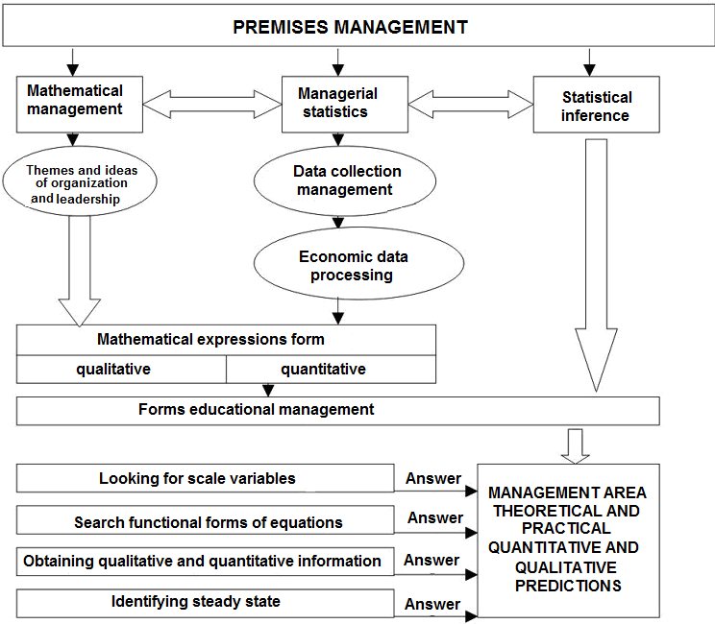
Figure no. 1 Premises for formalization managerial doxometry
as qualitatively and quantitatively predictive area

Primary records management levels are followed by evaluations intuitive, seeking links between content and value observation data and the dimensions and qualities measured by modeling organization and leadership.
Thus, in the general context for management, identify causal relationships real structural bases deterministic. [13]
Some values from a range bounded by the size and quality of organization and management are determined probabilistic values history.
Unraveling the mechanisms of transformation of variables can specify relationships between them real structure of functional managerial process or phenomenon studied.
Highlighting the way and form in which one variable affects the other variable is the complexity actionable approach appearance or research organization and management.
The rule aims to reduce as much as possible to research the relationship managerial linear form.

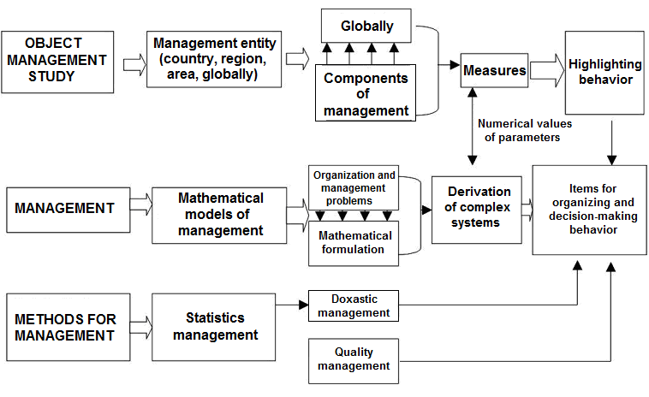
Figure no. 2 Subject, field and managerial methods of doxometry

The mechanism of transformation management is decomposed by doxometrice steps to obtain datasets considered to be true, then it is shown the maximum verisimilitude organization and management.
The reality of management and imaging model, type "cliché" at a given time for organizing and managing records some isomorphism, the contents of which remain contradictions between: 1) investigated the structure and management process; 2) stochastic causes and manifestations, and between 3) statements and actual empirical-rational organization and management. [14]
The finding marks above a mathematical differences doxometry and management and between treating quantitative empirical phenomenological and statistical organization and management problem, namely, rational structure research organization / management and general managerial causes of the problem.
In itself, doxometry by the fact that "measures" so induce quantification credible information determines "knowledge of organization and leadership" in the general sense, cognitive. From a rational model it is possible to build, so the generation, an empirical model which "pushes" into new areas evolutionary knowledge management using results-images (Figure 3.). [6]

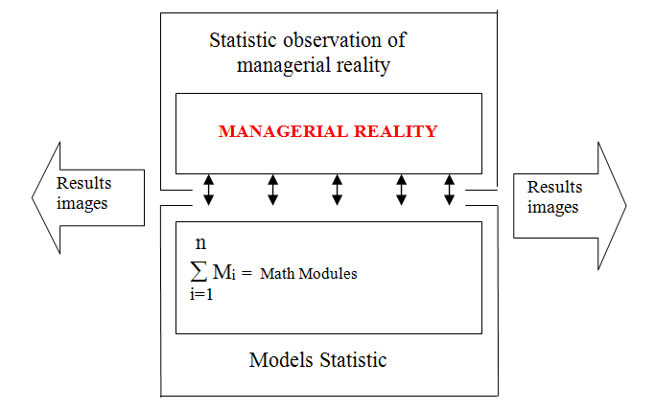
Figure no. 3 Getting results - mages usable for organization and management modification of complex systems
Doxometric models reconstruct the image management mechanisms that lead to new statistical processing sub-image results, management believes useful behavior of complex systems.
Organization and management models credible possibilities are generated by specific statistics, with which one experiences the whole set of alternative models of management to establish the likelihood is maximă.Statisticile entries (inputs) main management processes investigated. Reducible prediction may affect the extent that concentration or simplification operated by statistical calculations lose potentially permanent variables influence the organization's credibility and leadership. [15]
In fact, doxometria imaging is an extension or further development mathematized credible organization and management, characterized by credibility never ideal. Between micro and macro-dimensional relations are marked, respectively formalized a non-contradictory dualism. Applicability doxometrice models tracked by image-result simultaneously in two levels, namely micro and macro-management.
Adjusting doxometric representatives and estimation procedures or credibility is search tools alignments prediction with higher degree of verisimilitude in organization and management. Simplifying assumptions should not influence the growth trend of identifying managerial verisimilitude.
The framework for the interpretation of the managerial doxastic phenomenon
In systemic theory the system is defined as "a complex of interacting elements". Under the system rationality identified immediate, visible interaction is guided by scientific principles / quasi-scientific order and determined as a whole, typically tends to continuously improving its activity. For scientific purposes and practical system is defined as: "is a group, a complete assembly of natural and artificial elements that generate common goals (a common goal unites them)." [16]
The social organization is the most complex class system and within it there is the phenomenon of leadership. To identify the elements of a management system doxastic using a broader definition of the system, which is considered to be an organized grouping, a class of phenomena which satisfy the following requirements: be able to specify a set, a lot of elements of trust identifiable; be identifiable relationship of trust between at least some of them; certain trust relationships involve other relationships (infinite chain of relationships); a complex trust relationships at a given time involves some complex the next time, something that highlights the dynamics of the system.
Structurally, bringing together systems refers to specific parties, among which are listed:
a) Components of doxastic system. These are the elements and connections. Is a quality item (an object, a process, "a") of a phenomenon, a feeling of confidence etc. which is regarded as a part not subject to analysis. Secure elements quasi-infinite limits of any concrete or beyond the screen that opens metaphysical space and time.
b) Relations with the environment management system doxastic with exterior. În relation to the environment, the management system doxastic appears as an inclusion and has at least one input, one output, behavior and function that relates to credit, faith, the acceptance of the conventional good organization and / or leadership.
The concept of inclusion means that any system can fit into a larger structure reliable. The boundaries of a management system doxastic are relative, even trivial relative thresholds managerial system because confidence is reflected in a sharp relativity referential system of quantitative and qualitative possibilities. [17]
c) Characteristics and principles of operation of doxastic management systems. The value of the order is the task of credibility / conviction that one has solved the management system as a whole higher doxastic organized in an environment that produces disturbances credibility. Adaptability is the appropriation of keeping output unchanged command value in an environment of trust disruptive. Doxastic adaptive management system operates on the principle of trust relative independence of the output relative to the input of credibility as outstanding value. Input-output relation doxastice adaptive management systems can not be explained only by the linear causality of classical vision but resides in a specific causal confidence, being understood by the concept of stability.
Doxastic management control may be considered doxastic feedback. Regulator is connected with entry and exit. Following the reverse connection, it intervenes on the general managerial system doxastic (direct interventions on entry is made reliable and the system status).
d) Other operating characteristics and behavior. Orientation is acquiring doxastic management system to improve the level of responses under various disturbances of trust / custody.
The set of links of general system doxastic external environment is performed using material flows, energy and the information. [18]
Any entity is characterized by entries consist of the relations with other entities providing and outputs as relations with beneficiary units (Figure 4). [6]

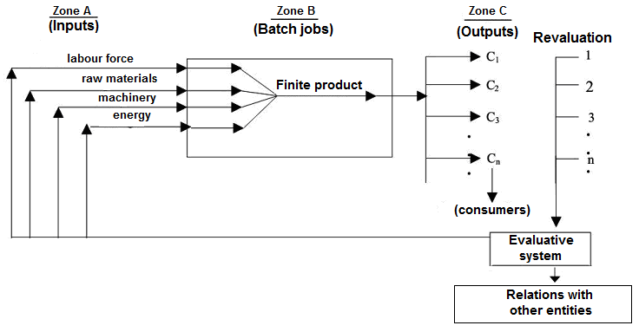
.
.
.
Figure no. 4 Entries algorithm processing (transformation) and
exit points in the doxastic managerial system

To carry out its specific entity is equipped with the means necessary managerial, operational and has a status of a control value determined by its plan. Subsystem leader link connecting subsystem subsystems driven by information.
Achieving control value as a sub-process reached flow of information (feed-back) from the makers. They take decisions doxastic managerial control subsystem, which they send to factors that modify their action, making meta-managerial value entry.

Doxastic managerial behavior
Superstate acting manager for behavior control circuit that manages to attract domestic solve problems that arise in the operation, internal capacities of inventiveness and initiative. [19]
Exemplary behavior and general manager of the company is composed superstate, in pursuit of the tool company, multiple independent relationships with the external environment, both the company and the manager.
This takes place by opening suprastability control circuit internal to seek means of establishing equilibrium; company and manager have dual adjustment possibilities, but are truly effective only when it manifests itself as superstate.
Intervention-compensation adjustment is necessary in some periods derived precisely because of the interactive site that it has the managerial system doxastic general manager.
Doxastic system helps understanding the concept of idea management process that aims adequacy doxastic managerial system organization in real life.
Essential aspects of confidence building process of obtaining information are doxastice management and use them to enable the development of specific organizational development, installation, stabilization, commissioning work effectively capabilities complex elements.
Doxastic management system concept allows highlighting the factors contributing to the evaluation meta-managerial decision.
Taking decisions without reference to a specific doxastic management system can be hazardous.
Reporting the results of any action organization and management structures of the managerial system doxastic competed in a successful outcome would increase the chances of future results imposed by adopting some decisions based on variables that contribute to their success.
The systemic perspective helps to explain maximum managerial processes doxastice the complexity and dynamic, meta-managerial whose essences can hardly be highlighted by other means of investigation.
Doxastic management system using the concept of trying to analyze the phenomenon of organization and leadership "as it is" in alignment characterized by credibility as a set of elements in predictive interaction.
Doxastic management system concept reflects a way of thinking management organization and management of the meta-database management. It provides a framework that allows to highlight the internal and external factors as an integrated whole, dominated by quasi-quantifiable confidence.
Doxastic content management system is used to explain the mechanism of manifestation of real life phenomena using unreality / ireality, or as a means to optimize operational management activity by building models based on system behavior. [6]
Doxastic management system is a complex projection which delimits the field in which credibility is investigated through the lens of organization and management, that is the objective basis, structural, spatial and temporal subjectivity objectified loaded.
The systemic frame doxastic the management process put in a new light not only means used to improve the performance, management and prognosis, but also other aspects such as specific phenomena of self-organization and self-regulation, aspects of the manifestation of the creative individual in a group, explaining responsibility the behavior of subjects like social elements.
The concept of doxastic management system can be established role to play each element of the system (compliance destination of each functional component) and then meta-managerial links that will be created in the system.

Conclusions
- The concept of doxastic management system reflects a way of thinking management organization and management of the meta-database management. It provides a framework that allows to highlight the internal and external factors as an integrated whole, dominated by quasi-quantifiable confidence.
- In relation to the environment, the management system doxastic appears as an inclusion and has at least one input, one output, behavior and function that relates to credit, faith, the acceptance of the conventional good organization and / or leadership.
- In management, doxometry gives widening / breadth significant organization and management issues, respectively actions vision extreme limits of measurement organization and management decision that may be of interest.
- Object, field and derivation methods are subordinate doxometry complex systems or to substantiate decision to behavior management.
- Doxometric adjust representatives and estimation procedures or credibility is search tools alignments prediction with higher degree of verisimilitude in organization and management. Simplifying assumptions should not influence the growth trend of identifying managerial verisimilitude.

References
[1] Audi, R. The Ethics of Belief. Doxastic Self-Conctrol and Intellectual Virtue, Synthese, no. 161/2008
[2] Audi, R. Doxastic Voluntarism and the Ethics of Belief, M. Setup, Ed. NY, Oxford, 2001
[3] Audi, R. Conceptele ştiinţei, Ed. Academiei Române, Bucureşti, 2010
[4] Carnap, R. Semnificaţie şi necesitate, Ed. Dacia, Cluj Napoca, 1972
[5] Cozic, M. Logical Omniscience and Rational Choise, Department of Philosophy, Sorbonne, Paris, 2004
[6] Gâf-Deac, I. Bazele managementului doxastic, FMP, Bucureşti, 2013,
[7] Gâf-Deac, M. Management general pentru economia bazată pe cunoaştere. Aplicaţii în sistemele productive operaţionale., Ed. Infomin, Deva, 2011
[8] Gâf-Deac, M. Managementul afacerilor, Ed. FRM, Bucureşti, 2008
[9] Gâf-Deac, M. Bazele practicii manageriale, Ed. Infomin, Deva, 2011
[10] Gâf-Deac, M. Management operaţional, Ed. Infomin, Deva, 2011
[11] Gâf-Deac, M. Management corporativ, FMP, București, 2014
[12] Gâf-Deac, M. Management general. Teorie şi aplicaţii, Ed. FRM, Bucureşti, 2008
[13] Gâf-Deac, M. Managementul producţiei, Ed. FRM, Bucureşti, 2008
[14] Gâf-Deac, M. Teoria deciziei, Ed. FRM, Bucureşti, 2004
[15] Gâf-Deac, M. Management. Baze generale şi legislative, Ed. FRM, Bucureşti, 2003
[16] Gâf-Deac, M. Management modern. Elemente de bază şi studii de caz, Ed. FRM, Bucureşti, 2005
[17] Gâf-Deac, M. Managementul modelării structurilor tehnologice, Ed. Infomin, Deva, 2002
[18] Gâf-Deac, M., Roșca I.P. Particularități regionale ale gestiunii corporative în România, Ed. ULIM, Chișinău, 2014
[19] Gâf-Deac, M. Management general. Teorie și practică, Editura FRM, Bucureşti, 2007
[20] Kocken, M. The Small-World, Ablex Norwood, New Jessey, 1989
[21] Ryan, S. Doxastic Compatibilism and the Ethics of Belief, no. 114/2003
[22] Vanditti, A. Indeterminancy and Endogenous Fluctuations in Two-Sector Growth Models with Externalities, Universite Aix Marseille III, 1996
[23] Watts, D.J. Small World, Ablex Norwood, New Jessey, 1989
[24] DEX online, 1998
[25] The Merriam - Webster Dictionary, Merriam Webster, 2004
[26] Online Etymology Dictionary, Douglas Harper, 2001
[27] Merriam-Webster Online Dictionary, London, 2010

