EFFICIENCY OF APPLYING NLP PRINCIPLES IN COMMUNICATION BETWEEN THE INTERNET OF THINGS AND SMART CITY CITIZENS

Alexandra Radu
Teseo UniversityPiazza Umberto I, San Cipriano Piacentino (Sa), 16 84099, Italy,
Tel.: +39 089 202 7721; 0040721260890; Email:a.radu@istitutoteseo.it
Abstract
Cities are expecting massive growth in the coming years; urbanization projects are looking at 2.5 billion more people living in cities. With that kind of growth, city government can no longer afford to lag behind in the digital landscape. Connecting, engaging and fulfilling of services between city and government will need to become increasingly digitized to keep up with rising demand while budgets remain tight, or in the near term, face deep cuts. Digital experiences can be made more efficient when complemented by NLP principles, image recognition and robotics, and these efficiencies translate to better experiences and reduced costs. In addition to larger smart city applications that cover utilities and traffic management, there are many opportunities to improve citizen engagement and city service delivery. Increasing citizen involvement in communication systems involving the idea of Smart City, automatically facilitates the population's access to the Internet of Things and determine assertive behavior, by applying the principles of neurolinguistics in communication between citizens and authorities through the cyber system that includes the citizen.

Keywords: neuro-linguistic, NLP principles, IoT, sensors, neuro-linguistic programming, quantitative encephalogram
JEL classification: Code 1230
Introduction

State and local government house myriad processes that require a great deal of human interaction to complete manual, repetitive tasks. Automating these processes could divert human energy to other tasks that require more thoughtful interaction, reducing costs while improving outcomes. However, the automation of certain services is not enough, as success depends on the citizen's openness to the use of these systems and thus, his involvement in the development of the smart city. In this regard, solutions like internet of things, computationally networked urbanism, product decision-making information systems, cyber-physical smart manufacturing systems, could be the key to the problem, but a key that must be doubled by a code to become effective. In our case, the code is actually neurolinguistic programming.
Neuro-Linguistic Programming was founded by behavioral modelers John Grinder and Richard Bandler to analyze and explore the patterns governing such complex processes of human behavior. The basic premise of NLP is that there is a redundancy between the observable macroscopic patterns of human behavior (for example, linguistic and paralinguistic phenomena, eye movements, hand and body position, and other types of performance distinctions) and patterns of the underlying neural activity governing this behavior.
If in the case of direct communication between two people the application of neurolinguistic principles and intuition or inculcation of certain behaviors is already possible and practicable, in terms of including the human individual in an extended cybernetic system, which involves communication through certain devices, we could talk about an innovative technique.
Several interconnected devices to which the human individual has access and is, in turn, connected, have been defined by the generic term Internet of Things.
The term "Internet of Things" was first used by Kevin Ashton in 1998, then officially introduced by the International Telecommunication Union (ITU) in 2005 through the ITU Internet Report.
Complete and correct is the definition offered by P. Guillemin and P. Friess: “The Internet of Things allows people and objects to be connected anytime, anywhere, with anything and anyone, using any path / network, as well as any service.”

1. Some basic elements of the neurolinguistic programming process
According to the introduction to the volume translated into Romanian, "The Roots of Neurolinguistic Programming", author Robert B. Dilts, the goal of Neuro-Linguistic Programming (NLP) is to integrate the macroscopic information about human behavior and experience available to each of us through our sensory experience with the unobservable microscopic information of the neuro- physiology of behavior and experience into a useful cybernetic model. I believe such an integration is essential if we ever hope to understand or utilize the properties governing the complex human processes of learning, memory, communication, choice, and motivation and how these affect the social and ecological environments of human beings. Infact, there is a very interesting study in this regard, published in May 2020, which talks about ”How discourse constraints influence neurolinguistic mechanisms during the comprehension of proverbs”, proving that: ” We use event-related brain potential (ERP) methodology to examine the influence of the linguistic markers literally speaking and figuratively speaking on the comprehension of proverbs (e.g., The cat is out of the bag). Our results show that slow cortical potentials at anterior electrode sites varied in amplitude across the proverbs as a function of the presence or absence of the markers, the presence and absence of discourse contexts, and the familiarity of the proverbs. The results demonstrate that the integration of literal meaning into context is easier than figurative meaning, and argues against models of figurative language processing that hold that comprehenders are obligated either to first process the literal or figurative sense of the trope.”( Ferretti, T. R., Katz, A. N., Schwint, C. A., Patterson, C., & Pradzynski, D. (2020). How discourse constraints influence neurolinguistic mechanisms during the comprehension of proverbs. Cognitive, Affective, & Behavioral Neuroscience, 20(3), 604-623.)
The mechanics of this process may be generalized into the following basic procedure:
a. An outcome is identified that is mutually acceptable to the facilitator (programmer) and the client (programmee). Explicit criteria for the successful achievement of the outcome are delineated.
b. One individual (the programmer) generates a communication, in the form of verbal and non-verbal behavior, in an attempt to direct or propel the programmee to the desired outcome. This communication elicits a response in the form of some access of information and return communication on the part of the other individual, the programmee. The interaction will take place on both the verbal and nonverbal level of response.
c. The two individuals may then work together to make distinctions in the programmee’s experience and response, both internally and externally:
1. via the programmer’s perception of the programmee’s external behavior within the specific contextual setting.
2. via explicit discussion and questioning about the programmee’s internal experience.

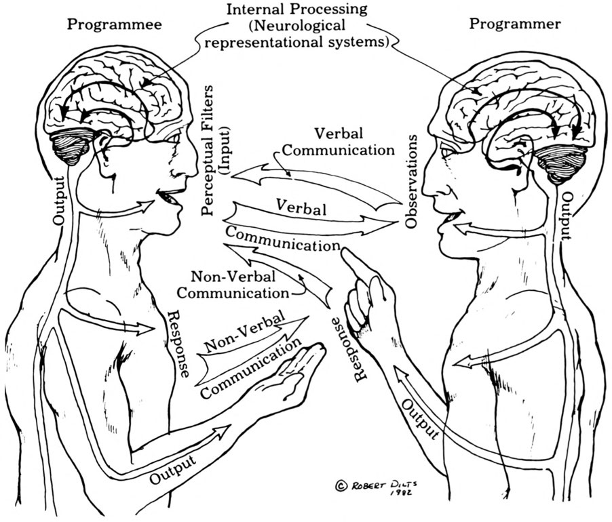
1. Photo 1, source: volume "The Roots of Neurolinguistic Programming", author Robert B. Dilts
At the neurolinguistic level, communication between two subjects therefore presupposes both an interaction at a cognitive level and one at an affective level, an objective and subjective involvement of the co-communicators. Thus, the communication process becomes complete and complex and involves the transmission of messages both at the conscious level and at the subliminal level. ” The evidence reviewed suggests that emotion is represented in the brain as a set of semantic features in a distributed sensory, motor, language and affective network. Also, emotion interacts with a number of lexical, semantic and syntactic features in different brain regions and timings. This is in line with the proposals of interactive neurocognitive models of language processing, which assume the interplay between different representational levels during on-line language comprehension.”( Hinojosa, J. A., Moreno, E. M., & Ferré, P. (2020). Affective neurolinguistics: towards a framework for reconciling language and emotion. Language, Cognition and Neuroscience, 35(7), 813-839.)
But what happens when communication is not between two human subjects, or when the human subject becomes part of a communication system that involves the presence of devices, the body of the human subject, turning into a device in itself. Is it possible to apply the principles of neurolinguistics in this process? If so, how can the communication of the human subject with the Internet of Things be improved through neurolinguistics?
In order to find out the possibility of transmitting messages that involve sensory experiences and emotions, through an Internet of Things type system, we must first clarify what the new reality of the Internet of Things consists of and how it works.

2. What is the internet of things?
The Internet of Things (IoT) is a concept that defines a world in which all objects (cars, apps, lighting systems, mobile devices, laptops, etc.) are connected to each other via the Internet. (Marwedel, P. (2021). Embedded system design: embedded systems foundations of cyber-physical systems, and the internet of things (p. 433). Springer Nature.)
The Internet of Things doesn't just rely on computers to exist. Every object, even the human body, can become part of the Internet of Things if it is equipped with certain electronic components. These parts certainly vary depending on what the object needs to perform, but they fall into two broad categories:
• the object must be able to capture data, usually via sensors.
• the object must be able to transmit this data elsewhere via the Internet.
A sensor and a connection, therefore, are the two primary electronic parts of an object included in the Internet of Things.( Liu, L., Guo, X., & Lee, C. (2021). Promoting smart cities into the 5G era with multi-field Internet of Things (IoT) applications powered with advanced mechanical energy harvesters. Nano Energy, 88, 106304.)
According to industry analysts, in 2015 there were between 10 and 20 billion objects connected to the Internet. This ecosystem of connected objects forms the foundation of the Internet of Things. The number of connected objects in 2015 was small compared to how many will be connected in 2020.
Estimates vary, but it is generally predicted that the number of connected objects by 2020 will be 40-50 billion, including everything from pens to housing, machinery and industrial equipment.
The graphical representation in figure 1 shows the objects that can be connected to each other via the Internet of Things, but it also shows that the Internet of Things not only includes, but places on a central position, the human subject.( Tun, S. Y. Y., Madanian, S., & Mirza, F. (2021). Internet of things (IoT) applications for elderly care: a reflective review. Aging clinical and experimental research, 33(4), 855-867.)
According to a study by RAND Europe, the annual global economic potential of the Internet of Things in all sectors concerned IoT has become one of the most challenging research topics in the field of ICT. The Internet of Things offers an amazing number of business opportunities, many of which are known only to experts in the field. In general, the media focuses on the segment of the consumer Internet of Things.( Elghaish, F., Hosseini, M. R., Matarneh, S., Talebi, S., Wu, S., Martek, I., ... & Ghodrati, N. (2021). Blockchain and the ‘Internet of Things' for the construction industry: research trends and opportunities. Automation in construction, 132, 103942.)
There is no doubt that consumer products have an important place in the universe of the Internet of Things, but they still remain a niche. Businesses that are not involved in the consumer market may mistakenly believe that the Internet of Things does not has something to offer them. However, the Internet of Things will have profound implications for all levels of business operations, regardless of industry type. The problems that companies have been facing for decades will diminish significantly and, in many cases, disappear.( Ghaleb, T. A., da Costa, D. A., & Zou, Y. (2021). On the popularity of internet of things projects in online communities. Information Systems Frontiers, 1-34.)
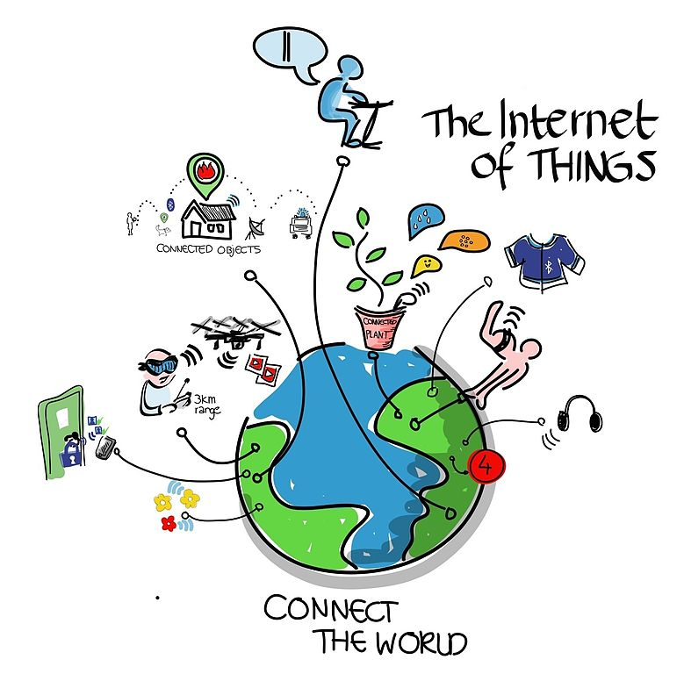
2. Photo 2. Internet of things, Photo source: https://nextgate.ro/internetul-tuturor-lucrurilor-internet-of-things-iot/

3. The central position of the human subject
Always placing the human subject in a central position, as a beneficiary, but also as a coordinator of operations carried out using the Internet of Things, then we refer to the disappearance of certain problems that companies face in the current context, we actually refer to solving certain problems also of the human resource, as an increasingly precarious labor force, but also as a capital that can be used to the maximum parameters, if the process of selection, training and distribution of this resource were carried out correctly. (Nasar, N., Ray, S., Umer, S., & Mohan Pandey, H. (2021). Design and data analytics of electronic human resource management activities through Internet of Things in an organization. Software: Practice and Experience, 51(12), 2411-2427.)
Here, too, comes the overwhelming role that the application of the principles of neurolinguistics could play in the communication between the human individual and the Internet, as an integral part of his life. But in order to be effective, it must also take into account the principles of neurolinguistics, infact to evaluate the emotional states, as well as the vast and deep cognitive experience of the subject).( Liu, Y., Zhang, W., Zhang, Q., & Norouzi, M. (2021). An optimized human resource management model for cloud-edge computing in the internet of things. Cluster Computing, 1-13.)
Neurolinguistics is, in fact, a "humanistic" science, as it considers that each individual is "equipped" from the beginning with all the skills and abilities he needs in order to modulate his own behavior.( Chashina, Z. V., Mochalov, E. V., Gryzhankova, M. Y., Zetkina, I. A., & Emelkina, I. V. (2021). Axiological Dominant of Psychological and Pedagogical Methods in Distance Education. Annals of the Romanian Society for Cell Biology, 2744-2751.)
Through this new "humanist movement", we return in other words to an era of absolute sincerity, in which the subject makes decisions based on strict and correct assessments, and the partner, even connected online, beyond a summary assessment, based on analysis of obvious data, can also perform a deeper analysis, including strategies developed at the mental level, translated by each individual who functions as an autonomous cyber system, through emotions, feelings and even, recording certain changes in the brain.( Aldhaheri, T. A., Kulkarni, S. B., & Bhise, P. R. (2021). Brain–Computer Interfaces and Neurolinguistics: A Short Review. Sustainable Communication Networks and Application, 655-670.)
Basically, the biggest mistake is to place the human individual outside the paradigm of the functioning of the Internet of Things, when in fact he is an integral part and central element of the whole system.
What does neurolinguistics bring in this regard? It is this approach of the human body as a cybernetic system, or as an element of a cybernetic system, in the case of its integration in the cycle of communication with the Internet of Things, as well as the placement of the human individual at the center of this system.

4. Applications of neurolinguistics in improving the communication of the Internet of Things with the human individual
Any event in one part of a cybernetic system (the human being, integrated into the Internet of Things system) will necessarily affect, in one way or another, all other parts of that system. Or, extending the neurolinguistic experience to the functioning of the cybernetic system as a whole, which also implies the existence of an internet of things in human existence, we can deduce that the effects of different parts of the system on each other can be modeled, predicted and changed.( Marwedel, P. (2021). Embedded system design: embedded systems foundations of cyber-physical systems, and the internet of things (p. 433). Springer Nature.)
Or from this hypothesis of modeling, prediction and change, can derive many possibilities of application of technologies that involve neurolinguistics in the process of communication between the human individual and the Internet of Things. For example, by eliminating the need to execute voice or preset commands, through cumbersome communication with an airtight and external system, the human individual, part of this system, could communicate through their own reactions, certain needs. (Zhan, K. (2021). Sports and health big data system based on 5G network and Internet of Things system. Microprocessors and Microsystems, 80, 103363.)
The temperature of the house could be regulated by a simple assessment of the level of energy comfort of the body of the individual or individuals living in that habitat(”Internet of things is perceived today as a key opportunity for commercial development in different sectors of activities, the new IoT Smart home ecosystem, is based on a lot of sensors and actuators that can make life in the home more pleasant and more safety for its occupant, in this article we distinguish the communication protocols used in this IoT ecosystem, their modes of operation, and we analyze their performance.”, Zemrane, H., Baddi, Y., & Hasbi, A. (2020). Internet of things smart home ecosystem. In Emerging Technologies for Connected Internet of Vehicles and Intelligent Transportation System Networks (pp. 101-125). Springer, Cham.), the assessment of physiological reactions (blinking, response speed, changing physiognomy, etc.) could help implement systems, parental control (the child no longer has to simply confirm his age in order to have access to certain information that could negatively influence him, but will have to communicate with the device, responding to certain stimuli, without being able to and hide the conditions caused by viewing images or accessing games), or could help the staff selection process (comparative assessment of the candidate's reactions will help the employer to obtain important information about the veracity of the information provided) and last but not least, could help stop bank fraud.( Singh, S., Ra, I. H., Meng, W., Kaur, M., & Cho, G. H. (2019). SH-BlockCC: A secure and efficient Internet of things smart home architecture based on cloud computing and blockchain technology. International Journal of Distributed Sensor Networks, 15(4), 1550147719844159.)

5. Opportunities and risks
The growth rate of e-commerce sales is expected to be at an incredible level of 265%. In 2017, e-commerce retail sales amounted to $ 2.3 trillion, and by 2021 - just four years later - revenues are estimated to reach $ 4.88 trillion.
All opportunities present a certain level of risk, and when it comes to the Internet of Things, the risks are just as important as the rewards. For example, any object connected to the Internet is an entry point through which cybercriminals can enter a company's system.( Bertino, E., & Islam, N. (2017). Botnets and internet of things security. Computer, 50(2), 76-79.)
In this context, stopping bank fraud could facilitate and encourage online commerce, protecting the individual and discouraging unwanted initiatives.
Making a virtual "fingerprint" of the individual will help the quantitative and comparative assessment of his reactions, in relation to various stimulus emitted by the cyber system of which he is part.( Sadeeq, M. A., Zeebaree, S. R., Qashi, R., Ahmed, S. H., & Jacksi, K. (2018, October). Internet of Things security: a survey. In 2018 International Conference on Advanced Science and Engineering (ICOASE) (pp. 162-166). IEEE.)
The concepts of connected health system and smart medical devices have enormous potential, not only for organizations but also for the well-being of people in general. New types of tools for real-time health monitoring and improvement of medical decisions based on large patient data sets are some of the expected benefits.( Kishor, A., & Chakraborty, C. (2021). Artificial intelligence and internet of things based healthcare 4.0 monitoring system. Wireless Personal Communications, 1-17.)
In this sense, an application of overwhelming importance is the one that allows connecting the individual's medical file to the emergency system, interpreting the messages issued by his body and transmitting them to the emergency system, so that the life of the individual can be saved in extreme situations.
The predictability of the system refers to its possibility to block certain operations and certain subjects considered dangerous or suspicious, but also to the prevention of crisis situations, in the case of patients with chronic disorders.
Here is how the intimate communication of the cybernetic system represented by the human body with the cybernetic system of the Internet of Things, can improve the virtual experience, leading to the creation of useful applications and control systems absolutely necessary for the continuation of life, in the form we imposes the present reality.
However, the obstacle of misinterpreting messages, both linguistic and neurolinguistic, should not be underestimated.( Ferreira, F. (2021). In defense of the passive voice. American Psychologist, 76(1), 145.)
From a linguistic point of view, for individuals from other parts of the globe, the obstacle is the obligation to have a thorough knowledge of English, this being considered a sinecvanon condition of using most applications.
It could be useful, in this sense, to represent functions through explicit icons and describe them in several universal languages, because we can only talk about the Internet of Things, in the context of the possibility of accessing this system globally, and therefore from individuals who they are not necessarily English speakers.
We do not deny that English is the language of modern technology and commerce, but this factor should not influence, in the opinion of the author of this study, the access of individuals to various facilities and the development of systems belonging to the future.( Li, Y. (2021). Construction of Internet of Things English terms model and analysis of language features via deep learning. The Journal of Supercomputing, 1-22.)

6. Technological challenges
With all the advantages offered, which seem to come from a Sience Fiction movie script, the Internet of Things also faces a number of technological challenges.
Thus, according to the article “THE INTERNET OF THINGS - A NEW PARADIGM OF INTERNET CONNECTION”, published in the Romanian Journal of Informatics and Automation, vol. 27, no. 1/2017, there are vulnerabilities of a technical nature, identified as:
• Scalability: The Internet of Things has a wider potential global scope than the conventional Internet.
Things, however, cooperate mainly in a local environment. So, basic functionalities such as communication and service discovery need to work just as efficiently in both small and large-scale environments;
• Acceptance and operation: Smart objects used on a daily basis should not be perceived as computers that require their users to configure and adapt them to certain situations. Mobile things, which are often used only sporadically, need to establish connections spontaneously and organize and configure themselves to suit their specific environment;
• Interoperability: just as the world of physical things is extremely diverse, in the Internet of Things each type of intelligent object has different capabilities for processing and communicating information.
• Software complexity: although smart object software systems operate with minimal resources, smart object management, as well as conventional integrated systems, requires a more extensive software infrastructure on the network and in the background servers;
• Data volumes: while some scenarios involve short, low-frequency communication, others, such as sensor networks, logistics, and large-scale "real-world awareness" scenarios require large volumes of data on central nodes or servers. network;
• Interpretation of data: supporting the users of intelligent objects involves interpreting as accurately as possible the context determined by sensors at the local level. In order for service providers to take advantage of the disparate data that will be generated, it must be possible to draw some generalizable conclusions from the interpreted data from the sensors.
However, generating useful information from raw data from sensors that can trigger a subsequent action is by no means an easy action;
• Security and confidentiality of personal data: in addition to the security and protection of the Internet, familiar to most users (such as the confidentiality of communications, the authenticity and credibility of communication partners, and the integrity of messages), there are other requirements that are important in the Internet of Things. For example, a user may allow things to have selective access to certain services or may prevent them from communicating with other things at certain times or in an uncontrolled manner; commercial transactions involving smart objects should be protected against unauthorized access by competitors to the market;
• Error tolerance: the world of things is much more dynamic and mobile than the world of computers, there are contexts that change quickly and in unexpected ways.
However, users want to rely on things that work properly. Structuring the Internet of Things in a robust and reliable way requires multilevel redundancy and the ability to automatically adapt to changed conditions;
• Power supply: things are usually not powered by the grid, so their intelligence must be powered by a self-sufficient source of energy. Although passive RFID transponders do not need their own power source, their functionality and range of communications are very limited. In many scenarios, mains batteries and power supplies are problematic because of their size and weight, and especially because of maintenance requirements. Unfortunately, battery technology is progressing relatively slowly, and "energy harvesting", ie the generation of electricity from the environment (using differences in temperature, vibration, air currents, light, etc.), is not yet sufficiently developed to meet the energy requirements of current electronic systems in most application scenarios. There is hope for future low-power processors and communications units for integrated systems that can run on much less power. Energy saving is an important factor not only in hardware and system architecture, but also in software, for example, the implementation of the protocol stack, where each transport byte will have to justify its existence.

7. Solutions
There are already wireless sensors without batteries that can transmit their information from a distance of a few meters. Like RFID systems, they get the energy they need, either remotely or from the measurement process itself, for example by using piezoelectric or pyroelectric materials to measure pressure and temperature; (Takahashi, R., Yukita, W., Sasatani, T., Yokota, T., Someya, T., & Kawahara, Y. (2021). Twin Meander Coil: Sensitive Readout of Battery-free On-body Wireless Sensors Using Body-scale Meander Coils. Proceedings of the ACM on Interactive, Mobile, Wearable and Ubiquitous Technologies, 5(4), 1-21.)
• Interaction and short-range communications: Wireless communications within a few centimeters are sufficient, for example, if one object is touched by another object. If such short distances are involved, very little energy is required, the approach is simplified (often there is only one possible destination) and there is usually no risk of interception. NFC is an example of this type of communication. Like RFID, it uses inductive coupling. During communication, one partner is in active mode and the other can be in passive mode. Active NFC units are small enough to be used in mobile phones; passive units are similar to RFID transponders and are significantly smaller, cheaper and do not need their own power source;
• Wireless communications: in terms of energy, wireless technologies such as GSM, UMTS, Wi-Fi and Bluetooth are much less appropriate; Newer WPAN standards such as ZigBee and others still under development may have narrower bandwidth, but they use significantly less power.
On the other hand, there are risks regarding the misinterpretation of the messages issued by the human individual at the neurolinguistic level.( Katan, D., & Taibi, M. (2021). Translating cultures: An introduction for translators, interpreters and mediators. Routledge.)
In this sense, there are risks related to the misinterpretation of body temperature and the transmission of the message that the evaluated organism is ill or feels a state of discomfort. Here comes the need for quantitative evaluation of the collected data, because the frequent blinking or the change of breathing rhythm, can transmit different messages that induce the risk of an erroneous evaluation of the individual's condition. In the pandemic context, this initial online health assessment is becoming essential. ( Salvatore, C., Roberta, F., Angela, D. L., Cesare, P., Alfredo, C., Giuliano, G., ... & Vittorio, M. (2021). Clinical and laboratory data, radiological structured report findings and quantitative evaluation of lung involvement on baseline chest CT in COVID-19 patients to predict prognosis. La radiologia medica, 126(1), 29-39.)
Conclusion

From a technical point of view, the correct application and capitalization of all the advantages that the involvement of neurolinguistics could bring in the complex communication that involves the integration of the human body in the IoT cybernetic system, the discovery of new methods to integrate the body in the cybernetic system that includes all the necessary elements and the security and improvement of the already existing communication systems, including the ways of evaluating the messages issued by the human individual, at linguistic and neurolinguistic level.
IoT is an emerging technology that creates a massive network of things communicating with one another. It encompasses a broad set of technologies, hardware and software stacks. Data, humans, devices and communication are critical elements of an IoT ecosystem. For a developing country such as India, which has quite limited technology penetration at the national level, an efficient architecture for IoT needs to be based on present technology advances, capabilities that provide affordable and sustainable solution, and entrepreneurial and social value. Smart city is an important concept for the development of any nation. It is crucial for government of India to offer different services to its citizens and IoT helps significantly to achieve this purpose. It will be possible to communicate transparently and seamlessly with large number of homogeneous and heterogeneous systems, while having selected access to data for designing numerous digital services.( Sarin, G. (2016, March). Developing smart cities using Internet of Things: An empirical study. In 2016 3rd International Conference on Computing for Sustainable Global Development (INDIACom) (pp. 315-320). IEEE.)
The purpose of smart city is to enhance the optimal utilization of scarce resources and improve the resident’s quality of live. The smart cities employed Internet of Things (IoT) to create a sustainable urban life. The IoT devices such as sensors, actuators, and smartphones in the smart cities generate data. The data generated from the smart cities are subjected to analytics to gain insight and discover new knowledge for improving the efficiency and effectiveness of the smart cities. Recently, the application of deep learning in smart cities has gained a tremendous attention from the research community. However, despite raise in popularity and achievements made by deep learning in solving problems in smart cities, no survey has been dedicated mainly on the application of deep learning in smart cities to show recent progress and direction for future development. (Barlow, M., & Levy-Bencheton, C. (2018). Smart cities, smart future: Showcasing tomorrow. John Wiley & Sons.)

References
[1] "The Roots of Neurolinguistic Programming", author Robert B. Dilts, Meta Publications, p. 7, 175, 1983.
[2] Geschwind, N.: Language and the Brain, Sci Am 226:76-83, 1972
[3] Grinder, J., Bandler, R: The Structure of Magic, Vol. I and, II, Science and Behavior Books Inc, 1975, 1976
[4] Bateson, G.: Steps to an Ecology of Mind, Ballantine Books, 1972.
[5] John, E. R.: a model of Consciousness, 1975.
[6] Pribram, K.: Languages of the Brain, Prentice-Hall, Inc., 1971.
[7] Morrell, F. et al.:”Electroencephalography”, Clinical Neurophysiology, Vol. 23, 1967.
[8] Nuwer M. Assessment of digital EEG, quantitative EEG, and EEG brain mapping: Report of the American Academy of Neurology and the American Clinical Neurophysiology Society. Neurology. 1997;49(1):277–92.

[9] WEBER, R. H.; WEBER, R.: Internet of Things. Legal Perspectives. Springer Berlin Heidelberg, 135 p., 2010.

[10] ATZORI, L.; IERA, A.; MORABITO, G.: Understanding the Internet of Things: definition, potentials, and societal role of a fast evolving paradigm. Ad Hoc Networks, Vol. 56, 2017, pp. 122-140.
[11] Ferretti, T. R., Katz, A. N., Schwint, C. A., Patterson, C., & Pradzynski, D. (2020). How discourse constraints influence neurolinguistic mechanisms during the comprehension of proverbs. Cognitive, Affective, & Behavioral Neuroscience, 20(3), 604-623.
[12] Hinojosa, J. A., Moreno, E. M., & Ferré, P. (2020). Affective neurolinguistics: towards a framework for reconciling language and emotion. Language, Cognition and Neuroscience, 35(7), 813-839.
[13] Singh, S., Ra, I. H., Meng, W., Kaur, M., & Cho, G. H. (2019). SH-BlockCC: A secure and efficient Internet of things smart home architecture based on cloud computing and blockchain technology. International Journal of Distributed Sensor Networks, 15(4), 1550147719844159
[14] Sadeeq, M. A., Zeebaree, S. R., Qashi, R., Ahmed, S. H., & Jacksi, K. (2018, October). Internet of Things security: a survey. In 2018 International Conference on Advanced Science and Engineering (ICOASE) (pp. 162-166). IEEE.
[15] Li, Y. (2021). Construction of Internet of Things English terms model and analysis of language features via deep learning. The Journal of Supercomputing, 1-22.
[16] Marwedel, P. (2021). Embedded system design: embedded systems foundations of cyber-physical systems, and the internet of things (p. 433). Springer Nature.
[17] Liu, L., Guo, X., & Lee, C. (2021). Promoting smart cities into the 5G era with multi-field Internet of Things (IoT) applications powered with advanced mechanical energy harvesters. Nano Energy, 88, 106304.
[18] Tun, S. Y. Y., Madanian, S., & Mirza, F. (2021). Internet of things (IoT) applications for elderly care: a reflective review. Aging clinical and experimental research, 33(4), 855-867.
[19] Elghaish, F., Hosseini, M. R., Matarneh, S., Talebi, S., Wu, S., Martek, I., ... & Ghodrati, N. (2021). Blockchain and the ‘Internet of Things' for the construction industry: research trends and opportunities. Automation in construction, 132, 103942.
[20] Ghaleb, T. A., da Costa, D. A., & Zou, Y. (2021). On the popularity of internet of things projects in online communities. Information Systems Frontiers, 1-34.
[21] Nasar, N., Ray, S., Umer, S., & Mohan Pandey, H. (2021). Design and data analytics of electronic human resource management activities through Internet of Things in an organization. Software: Practice and Experience, 51(12), 2411-2427.
[22] Liu, Y., Zhang, W., Zhang, Q., & Norouzi, M. (2021). An optimized human resource management model for cloud-edge computing in the internet of things. Cluster Computing, 1-13.
[23] Chashina, Z. V., Mochalov, E. V., Gryzhankova, M. Y., Zetkina, I. A., & Emelkina, I. V. (2021). Axiological Dominant of Psychological and Pedagogical Methods in Distance Education. Annals of the Romanian Society for Cell Biology, 2744-2751.
[24] Aldhaheri, T. A., Kulkarni, S. B., & Bhise, P. R. (2021). Brain–Computer Interfaces and Neurolinguistics: A Short Review. Sustainable Communication Networks and Application, 655-670.
[25] Marwedel, P. (2021). Embedded system design: embedded systems foundations of cyber-physical systems, and the internet of things (p. 433). Springer Nature.
[26] Zhan, K. (2021). Sports and health big data system based on 5G network and Internet of Things system. Microprocessors and Microsystems, 80, 103363.
[27] Ferreira, F. (2021). In defense of the passive voice. American Psychologist, 76(1), 145.
[28] Takahashi, R., Yukita, W., Sasatani, T., Yokota, T., Someya, T., & Kawahara, Y. (2021). Twin Meander Coil: Sensitive Readout of Battery-free On-body Wireless Sensors Using Body-scale Meander Coils. Proceedings of the ACM on Interactive, Mobile, Wearable and Ubiquitous Technologies, 5(4), 1-21.
[29] Katan, D., & Taibi, M. (2021). Translating cultures: An introduction for translators, interpreters and mediators. Routledge.
[30] Salvatore, C., Roberta, F., Angela, D. L., Cesare, P., Alfredo, C., Giuliano, G., ... & Vittorio, M. (2021). Clinical and laboratory data, radiological structured report findings and quantitative evaluation of lung involvement on baseline chest CT in COVID-19 patients to predict prognosis. La radiologia medica, 126(1), 29-39.
[31] Sarin, G. (2016, March). Developing smart cities using Internet of Things: An empirical study. In 2016 3rd International Conference on Computing for Sustainable Global Development (INDIACom) (pp. 315-320). IEEE.
[32] Barlow, M., & Levy-Bencheton, C. (2018). Smart cities, smart future: Showcasing tomorrow. John Wiley & Sons.

Sitography
Statistician. (2018, March). Worldwide retail e-commerce sales from 2014 to 2021. Retrieved from https://www.statista.com/statistics/379046/worldwide-retail-e-commerce-sales/. Article
“The Internet of all thnigs”, https://nextgate.ro/internetul-tuturor-lucrurilor-internet-of-things-iot/. Article
https://nextgate.ro/internetul-tuturor-lucrurilor-internet-of-things-iot/

